Angular
Angular is a JavaScript open-source front-end web application framework. It is primarily sustained by Google together with an extended community of people and companies, to approach many of the challenges faced when developing single page, cross platform, performant applications. It is fully extensible and works well with other libraries.

Angular is a javascript framework which allows you to create reactive single page application(SPA)

Angular cli—command line interface
Working with Angular:
Install node file from https://nodejs.org/en/
Once the node is installed on the computer.
In command prompt give the following commands:
npm install -g @angular/cli
this will run the cli and install npm globally on your machine
Create a new folder naming it Angular(Can be any name). Open command prompt from that location.
c:\Angular >ng new first-angular-app
the above command will create a new angular project in the given folder with all angular related files.
cd first-angular-app
c:\Angular\first-angular-app>ng serve
the above command will build the application and you can see the output in the browser on
localhost:4200

How Angular starts the application:
Make sure the ng serve keeps running all the time for the application to update any new changes in the application.
If you observe the output index.html file, it is a normal html file which has a customised component. The output looks different from html file.
Somehow index.html keeps changing as it doesn’t look like what it is. The cli has created a root component which is called while building. Lets look how,

Observe app.component,ts which contains the component which is available in index,html file.
How is angular triggered.
Main.ts is the first code which gets executed.
In you observe the code it has
platformBrowserDynamic().bootstrapModule(AppModule)

this specifies that the file that needs to be started with AppModule
this in turn calls the app.module.ts which has the following line of code
import { BrowserModule } from '@angular/platform-browser';
import { NgModule } from '@angular/core';

import { AppRoutingModule } from './app-routing.module';
import { AppComponent } from './app.component';

@NgModule({
declarations: [
AppComponent
]
imports: [
BrowserModule,
AppRoutingModule
],
providers: [],
bootstrap: [AppComponent]
})
export class AppModule { }

this file now calls the app.component.ts file which has the following selector code;
@Component({
selector: 'app-root',
templateUrl: './app.component.html',
styleUrls: ['./app.component.css']
})

This component has the selector name and the source html file name which contains the html tags.
Open the app.component.html and you see the html code. That which is the output of the page.
(can be any html content)
<h1>
My First Application !!!
</h1>

The above selector is found in index.html
<body>
<app-root></app-root>
</body>

Angular in the end is a JS frame work changing your DOM(HTML) at run time .

Components:
Are a key feature in angular. You build your application with a set of components which are created by us. There will be a main root component and we nest a set of more components to the same. Each component will have its own html, css and also business logic.
How to create components:
There are two ways of creating components.
1.Manually
2.Using CLI

When we create a new component, their selectors will not be added to the index,html but will be added to the root components.
Goto app folder-right click -create new folder-name it server
Right click on serve folder-add new file-name it server.component.ts

Open server.component.ts and write the following code

export class ServerComponent
{

}

Include this above the export
import { Component } from '@angular/core';

@Component(
{
selector: 'app-server',
templateUrl:'./Server.component.html'
})

So the file looks like this

import { Component } from '@angular/core';

@Component(
{
selector: 'app-server',
templateUrl:'./Server.component.html'
})

export class ServerComponent
{

}

Inorder to use @component you have to import the component from @angular/core
Now inside the component we have to specify the selector name that will go into html file and the templateUrl which points to the html file. For this lets create a html file.
Right click on the server folder – Add New File- Server.component.html
In the HTML file put some HTML tags
<h1>My Server Component</h1>

Now its almost ready to use but before that we have to change the AppModule.
@ngModule has 4 properties.
1.declarations
2.imports
3.providers
4,bootstrap

Bootstrap is responsible to tell angular which component should be aware of at the time the application starts. Since we don’t change the index,html with the new modules don’t change anything in the bootstrap. We have to register the server component into @NgModule so the application can use it.

import { BrowserModule } from '@angular/platform-browser';
import { NgModule } from '@angular/core';

import { AppRoutingModule } from './app-routing.module';
import { AppComponent } from './app.component';
import { ServerComponent } from 'src/Server/Server.component';

@NgModule({
declarations: [
AppComponent,
ServerComponent
],
imports: [
BrowserModule,
AppRoutingModule
],
providers: [],
bootstrap: [AppComponent]
})
export class AppModule { }

imports allows us to add some modules into application. Some modules goes into angular as the angular itself I split up into modules. Browser module gives us all the base functions to start the App.
Once our component is registered in the module,lets use it. Lets go to app.component,html file and lets add the <app-server></app-server> in the html and save it and you see the changes on the browser.
<h1>
My First Application !!!
</h1>
<app-server></app-server>

This will show

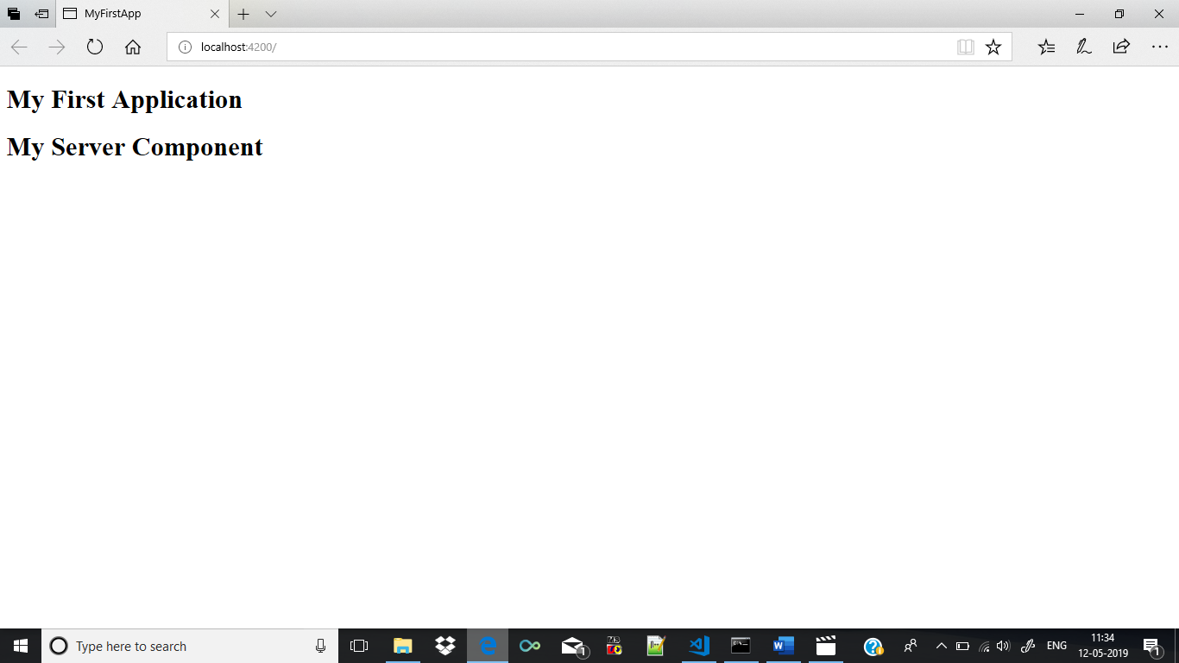

We have learnt how to create a component and include it in the application manually. The same can be done using cli . This is the second way of creating components.
Keep the ng-serve command prompt running and open a new command prompt from the same location. Give the below command
C:\Angular\my-first-app>ng generate component servers
Or
C:\Angular\my-first-app>ng g c servers
The above statement creates a new folder named server with some files
servers.component,ts
servers.component.html
servers.component.css
servers.component.spec.ts -> this file is used for testing purpose.Can ignore this file for now.

The above command also registers the component into the app.module.ts
import { BrowserModule } from '@angular/platform-browser';
import { NgModule } from '@angular/core';

import { AppRoutingModule } from './app-routing.module';
import { AppComponent } from './app.component';
import { ServerComponent } from 'src/Server/Server.component';
import { ServersComponent } from './servers/servers.component';

@NgModule({
declarations: [
AppComponent,
ServerComponent,
ServersComponent
],
imports: [
BrowserModule,
AppRoutingModule
],
providers: [],
bootstrap: [AppComponent]
})
export class AppModule { }

In the server.component.html file there will be some default HTML content. You can also nest the component that was manually created before. In servers.component,html
<p>
servers works!

</p>
<app-server></app-server>

If you open servers.component.ts
import { Component, OnInit } from '@angular/core';

@Component({
selector: 'app-servers',
templateUrl: './servers.component.html',
styleUrls: ['./servers.component.css']
})
export class ServersComponent implements OnInit {

constructor() { }

ngOnInit() {
}

}

You can see the selector. This is the selector that can be used on HTML files.
We can include this selector in app.component.html

<h1>My First Application</h1>
<app-servers></app-servers>

Now save the application and you see this in the browser.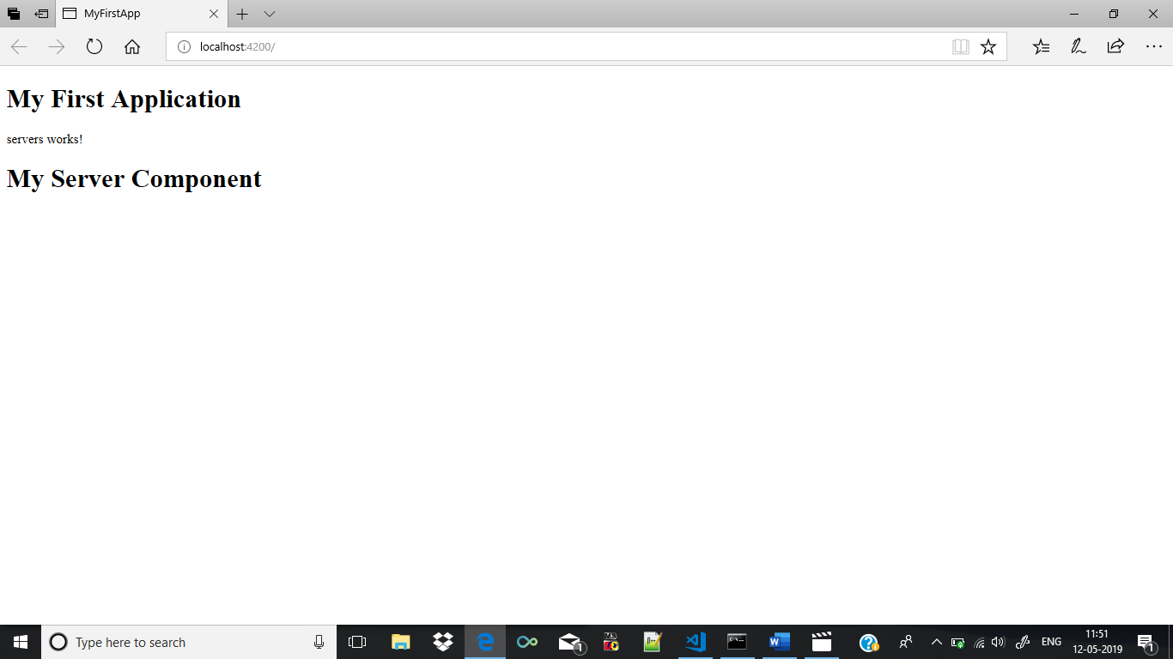

We can nest one component into another like the above.

Working with component Templates:

In the above servers component in the typescript file we have seen there was a templateUrl which linked to the html file.
import { Component, OnInit } from '@angular/core';

@Component({
selector: 'app-servers',
templateUrl: './servers.component.html',
styleUrls: ['./servers.component.css']
})
export class ServersComponent implements OnInit {

constructor() { }

ngOnInit() {
}

}

The templateUrl which is highlighted is used to link to the HTML file. We can change this templateUrl to simply template and give the HTML selectors and it works the same.
import { Component, OnInit } from '@angular/core';

@Component({
selector: 'app-servers',
template: '<h1>Inside template for servers</h1>',
styleUrls: ['./servers.component.css']
})
export class ServersComponent implements OnInit {

constructor() { }

ngOnInit() {
}

}

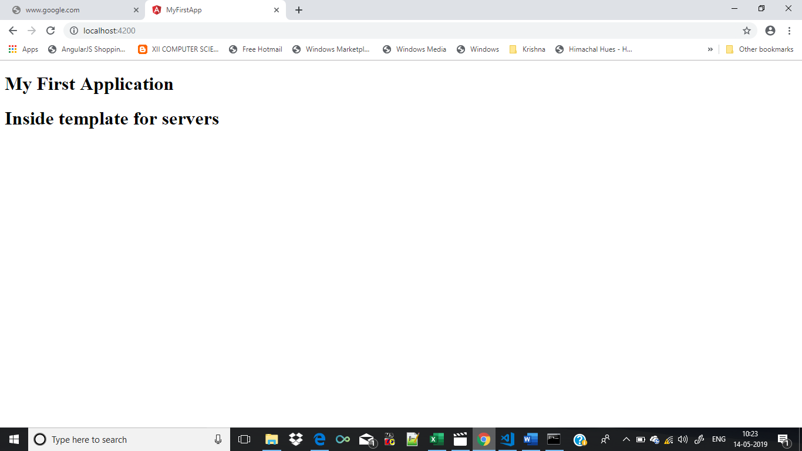

Or
import { Component, OnInit } from '@angular/core';

@Component({
selector: 'app-servers',
template: '<app-server></app-server>',
styleUrls: ['./servers.component.css']
})
export class ServersComponent implements OnInit {

constructor() { }

ngOnInit() {
}

}

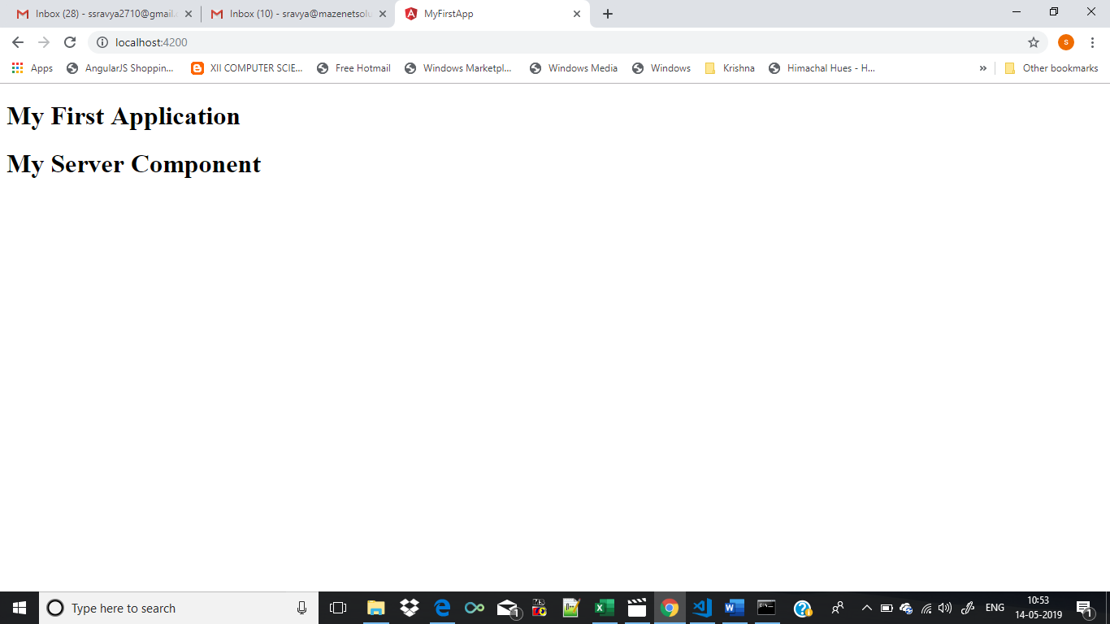

This approach is called an inline template and can be used when you have not more than 3 lines in the HTML file.
Working with component styles:
If you observe every component has a css file. You can style the component by adding styles to the components.
So add the following style to app.component.css

h1
{

color:red;
}

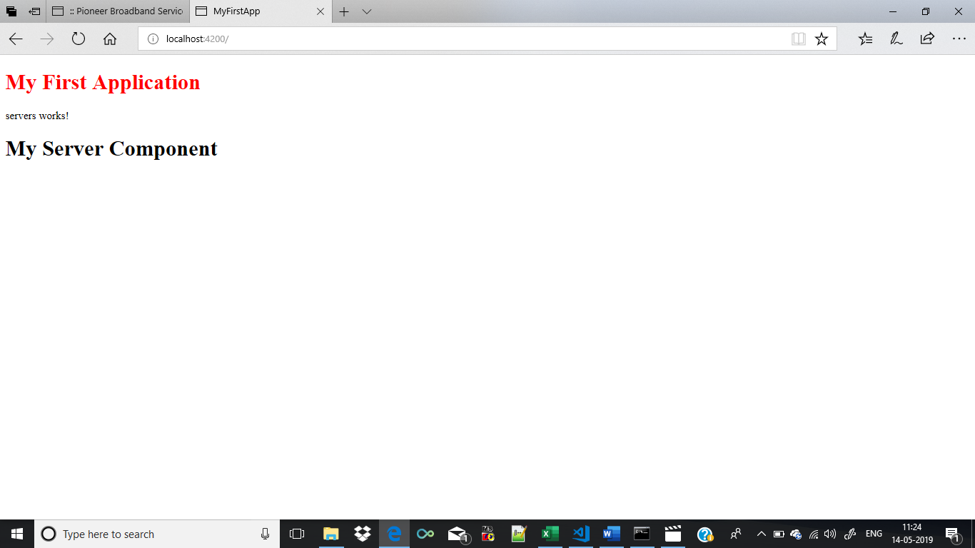

The same thing can be given in the typescript file in the component . Just like the inline template we also have inline styles. Comment the styleUrl and include the styles . You can include multiple styles. In order to give multiline style instead of single quotation use back tick.
` ` .
In app.component.ts

import { Component } from '@angular/core';

@Component({
selector: 'app-root',
templateUrl: './app.component.html',
// styleUrls: ['./app.component.css']
styles:[`
h1
{
background-color:red;
}
`]
})
export class AppComponent {
title = 'Done!!!';
}
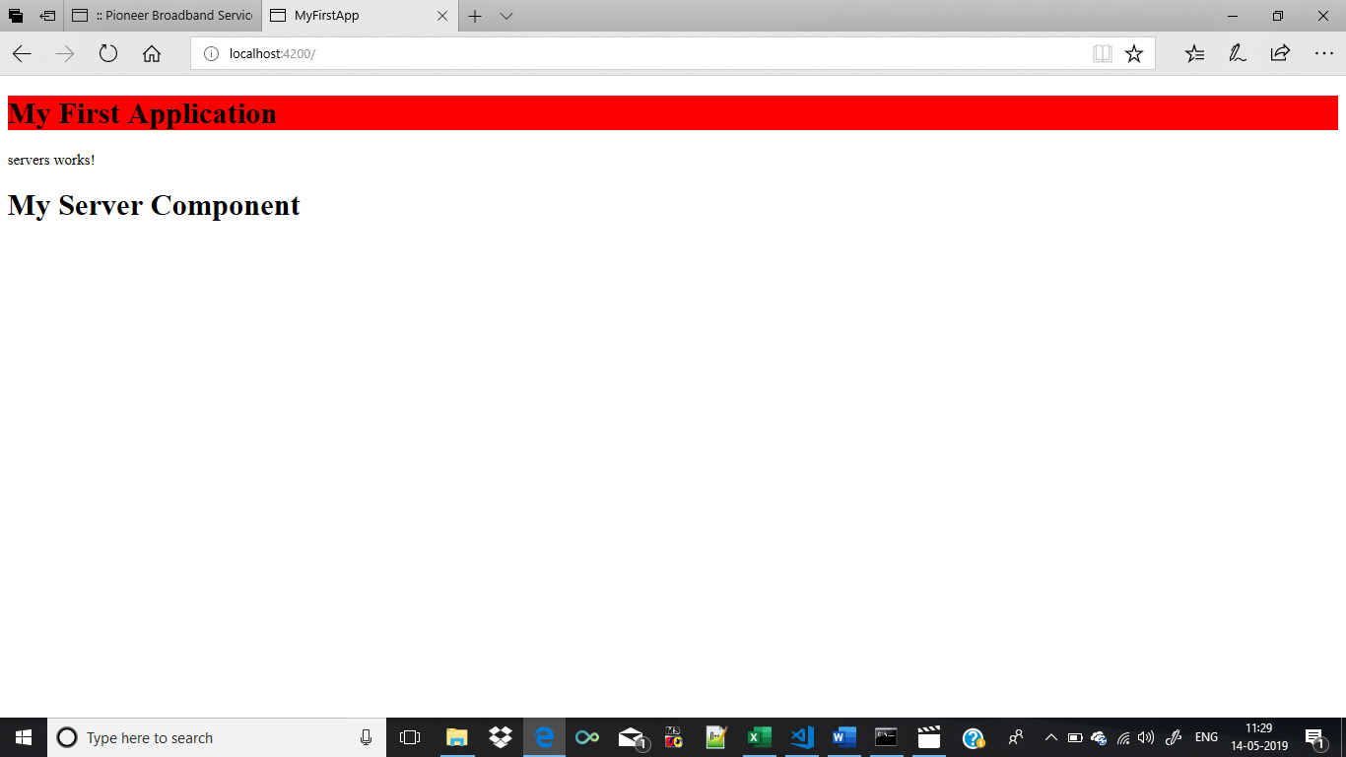

Component Selectors:
The selectors that we have are the selectors used in css. These can also be used like attributes. For that in the selector we have to enclose them in square brackets.
import { Component, OnInit } from '@angular/core';

@Component({
selector: '[app-servers]',
templateUrl: './servers.component.html',
styleUrls: ['./servers.component.css']
})
export class ServersComponent implements OnInit {

constructor() { }

ngOnInit() {
}

}

<h1>My First Application</h1>

<app-servers></app-servers>

But this would generate error on the browser because this selector cannot be used like a HTML element anymore. It should be called like an attribute.
Change the above HTML code to the below code
<h1>My First Application</h1>

<div app-servers> </div>

To select the same element using class then we have to use the dot operator before instead of a square bracket.
import { Component, OnInit } from '@angular/core';

@Component({
//selector: '[app-servers]',
selector:'.app-servers',
templateUrl: './servers.component.html',
styleUrls: ['./servers.component.css']
})
export class ServersComponent implements OnInit {

constructor() { }

ngOnInit() {
}

}

In the HTML file we use the class attribute to load that component.
<h1>My First Application</h1>

<div class=app-servers> </div>

Selecting by id doesn’t work in angular and hover also doesn’t work in angular.

Understanding Data Binding
Communication between typescript code and the template (UI).
There are different ways of databinding. In order to show some output on the HTML we can either use
1.String interpolation
2.Property Binding
When you click on a button we may want to trigger something in typescript. Then we use Event Binding.
Databinding=communication
Typescript Code
(Business Logic)
Typescript Code
(Business Logic)
Output Data
React to user events

Output Data:
String Interpolation({{data}})
Property Binding ([property]=”data”)
React To user events:
Event Binding((event)=”expression”)

Combination of Both:
Two-Way-Binding([(ngModel)]=”data”)

What is String Interpolation :
When you want the output to be dynamic then instead of giving static data we can give dynamic data. This data can be derived in the typescript file and called in the HTML.
So in server.component.ts file let us include some variables inside the class.

import { Component } from '@angular/core';

@Component(
{
selector: 'app-server',
templateUrl:'./Server.component.html'
})

export class ServerComponent
{
Servername: string="MyServer";
serverstatus:string="Offline";

}

I have declared two string variables servername and serverstatus. I have also specified some values to the variables.
Any expression which can be resulted to a string in the end has to return a string. We cannot write multi line expression or a for or if expressions. You can use a ternary expression though.
In the server.component.html file

<h1>My Server Component</h1>
<p>The Server Name is {{Servername}} and the server status is {{serverstatus}}</p>

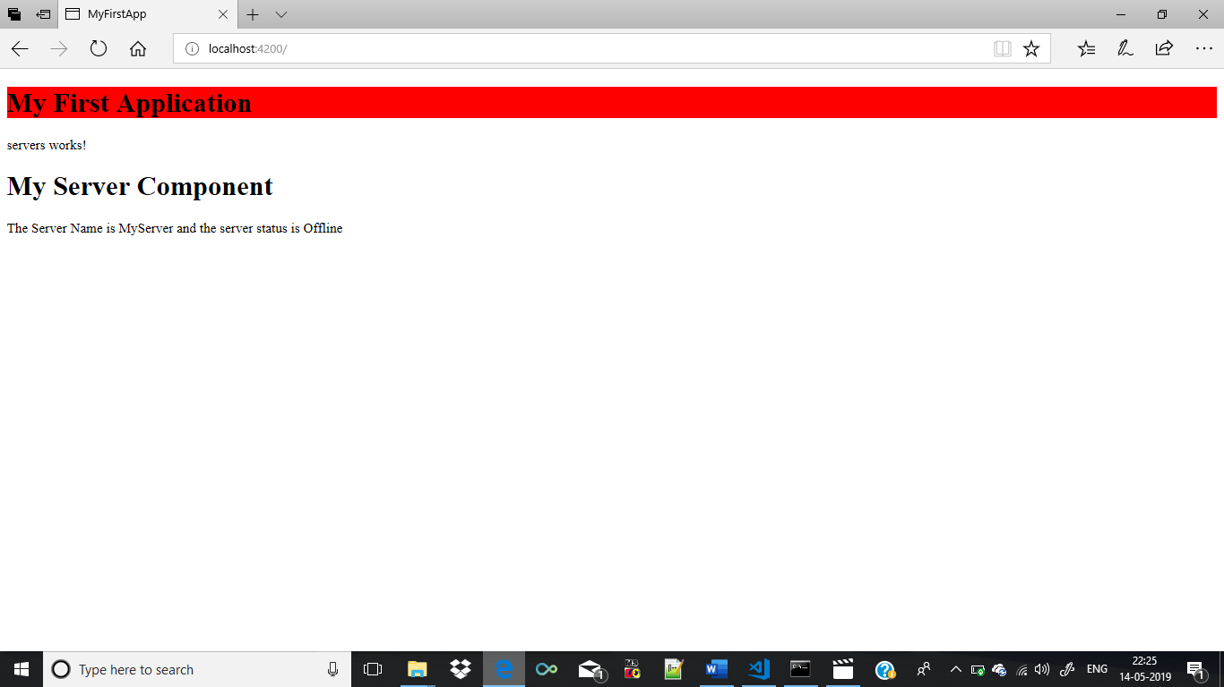

Angular 7 Directives
Directives are instructions in the DOM. They specify how to place your components and business logic in the Angular.
Directives are js class and declared as @directive. There are 3 directives in Angular.
- Component Directives
- Structural Directives
- Attribute Directives
Component Directives: Component directives are used in main class. They contain the detail of how the component should be processed, instantiated and used at runtime.
Structural Directives are directives which change the structure of the DOM by adding or removing elements.
There are three built-in structural directives, NgIf, NgFor and NgSwitch.
These directives work by using the HTML5 <ng-template> tag. This is a new tag in HTML which is specifically designed to hold template code. It can sit under the body element but any content inside it is not shown in the browser.
Using ng-template we can write an ngIf expression as:
TypeScript
Copy<ng-template [ngIf]='condition'>
<p>I am the content to show</p>
</ng-template>
If we go back to our joke app example and replace the hiding and showing of a joke with this template version of ngIf we would end up with:
TypeScript
Copy<ng-template [ngIf]="!data.hide">
<p class="card-text">
{{ data.punchline }}
</p>
</ng-template>
The NgFor version is slightly more complex:
TypeScript
Copy<ng-template ngFor (1)
let-j (2)
[ngForOf]="jokes"> (3)
<joke [joke]="j"></joke>
</ng-template>
This is the NgFor directive itself.
This is another way of declaring a template local reference variable, equivalent to #j.
[ngForOf] is an input property of the NgFor directive.

Angular Template-driven Forms is one of the two ways of building forms in Angular. In this tutorial, we will learn how to build a simple Template-driven forms example app. First, we build a simple HTML form using a few form elements. The ngForm directive will convert it to the Template-driven form and create the top-level FormGroup control. Next, we use the ngModel directive to create the FormControl instance for each of the HTML form elements. Later, we will learn how to submit the form data to the component class. We will also learn how to initialize or reset the form data and use the data binding to access the data in the component class.
The Template-driven forms
- The form is set up using ngForm directive
- controls are set up using the ngModel directive
- ngModel also provides the two-way data binding
- The Validations are configured in the template via directives

Template-driven forms
- Contains little code in the component class
- Easier to set up
While they are
- Difficult to add controls dynamically
- Unit testing is a challenge

Create the Example Application
Use ng new to create a new application
1  2  3 | ng new tdf --routing=true --style=css
Run ng serve and verify if everything is installed correctly.

Import FormsModule
To work with Template-driven forms, we must import the FormsModule. We usually import it in root module or in a shared module. The FormsModule contains all the form directives and constructs for working with forms
Open the app.module.ts and add the import { FormsModule } from '@angular/forms'; to it.
And also add the FormsModule to the imports metadata property array
1  2  3  4  5  6  7  8  9  10  11  12  13  14  15  16  17  18  19  20  21  22 | import { BrowserModule } from '@angular/platform-browser';  import { NgModule } from '@angular/core';  import { FormsModule } from '@angular/forms'; //import FormsModule  import { AppRoutingModule } from './app-routing.module';  import { AppComponent } from './app.component';  @NgModule({  declarations: [  AppComponent  ],  imports: [  BrowserModule,  AppRoutingModule,  FormsModule //Add in Imports Array  ],  providers: [],  bootstrap: [AppComponent]  })  export class AppModule { }

HTML Form
The first task is to build the template. The following is a regular HTML form. We enclose it in a <form> tag. We have included two text input (FirstName & LastName), a email (email), a radio button (gender), a checkbox (isMarried), and a select list (country). These are form elements.
1  2  3  4  5  6  7  8  9  10  11  12  13  14  15  16  17  18  19  20  21  22  23  24  25  26  27  28  29  30  31  32  33  34  35  36  37  38  39  40  41  42  43  44  45 | <form>  <p>  <label for="firstname">First Name</label>  <input type="text" id="firstname" name="firstname">  </p>  <p>  <label for="lastname">Last Name</label>  <input type="text" id="lastname" name="lastname">  </p>  <p>  <label for="email">Email </label>  <input type="text" id="email" name="email">  </p>  <p>  <label for="gender">Gender</label>  <input type="radio" value="male" id="gender" name="gender"> Male  <input type="radio" value="female" id="gender" name="gender"> Female  </p>  <p>  <label for="isMarried">Married</label>  <input type="checkbox" id="isMarried" name="isMarried">  </p>  <p>  <label for="country">country </label>  <select name="country" id="country">  <option selected="" value=""></option>  <option [ngValue]="c.id" *ngFor="let c of countryList">  {{c.name}}  </option>  </select>  </p>  <p>  <button type="submit">Submit</button>  </p>  </form>
Component Class
1  2  3  4  5  6  7  8  9  10  11  12  13  14  15  16  17  18  19  20  21  22  23  24  25  26  27  28 | import { Component } from '@angular/core';  @Component({  selector: 'app-root',  templateUrl: './app.component.html',  styleUrls: ['./app.component.css']  })  export class AppComponent {  title = 'Template driven forms';  countryList:country[] = [  new country("1", "India"),  new country('2', 'USA'),  new country('3', 'England')  ];  }  export class country {  id:string;  name:string;  constructor(id:string, name:string) {  this.id=id;  this.name=name;  }  }

ngForm
Once, we have a form with few form elements, the angular automatically converts it into a Template-driven form. This is done by the ngForm directive.
The ngForm directive is what makes the Angular template-driven forms work. But we do not need to add it explicitly. Angular adds it automatically
When we include FormsModule, the Angular is going to look out for any <form> tag in our HTML template. Angular does this via ngForm directive. ngForm directive automatically detects the <form> tag and automatically binds to it. You do not have to do anything on your part to invoke and bind the ngForm directive.
The ngForm does the following
- Binds itself to the <Form> directive
- Creates a top-level FormGroup instance
- CreatesFormControl instance for each of child control, which has ngModel directive.
- CreatesFormGroup instance for each of the NgModelGroup directive.
We can export the ngForm instance into a local template variable using ngForm as the key (ex: #contactForm="ngForm"). This allows us to access the many properties and methods of ngForm using the template variable contactForm
Hence, update the form element as shown below.
1  2  3 | <form #contactForm="ngForm">

FormControl
The FormControl is the basic building block of the Angular Forms. It represents a single input field in an Angular form. The Angular Forms Module binds the input element to a FormControl. We use the FormControl instance to track the value, user interaction and validation status of an individual form element. Each individual Form element is a FormControl.
We have six form elements in our HTML template. They are firstName, lastname, email, gender, isMarried & country. We need to bind them to FormControl instance. We do this by using the ngModel directive. Add the ngModel directive to each control as shown below.
1  2  3 | <input type="text" name="firstname" ngModel>
ngModel will use the name attribute to create the FormControl instance for each of the Form field it is attached.

Submit Form
Now have the template ready, except for the final piece i.e submitting data to the component.
We use the ngSubmit event, to submit the form data to the component class. We use the event binding (parentheses) to bind ngSubmit to OnSubmit method in the component class. When the user clicks on the submit button, the ngSubmit event will fire
1  2  3 | <form #contactForm="ngForm" (ngSubmit)="onSubmit(contactForm)">
We are passing the local template variable contactForm in onSubmit method. contactForm holds the reference to the ngForm directive. We can use this in our component class to extract the data from the form fields.

Final Template
Our final template is as shown below.
1  2  3  4  5  6  7  8  9  10  11  12  13  14  15  16  17  18  19  20  21  22  23  24  25  26  27  28  29  30  31  32  33  34  35  36  37  38  39  40  41 | <form #contactForm="ngForm" (ngSubmit)="onSubmit(contactForm)">  <p>  <label for="firstname">First Name</label>  <input type="text" name="firstname" ngModel>  </p>  <p>  <label for="lastname">Last Name</label>  <input type="text" name="lastname" ngModel>  </p>  <p>  <label for="email">Email </label>  <input type="text" id="email" name="email" ngModel>  </p>  <p>  <label for="gender">Geneder</label>  <input type="radio" value="male" name="gender" ngModel> Male  <input type="radio" value="female" name="gender" ngModel> Female  </p>  <p>  <label for="isMarried">Married</label>  <input type="checkbox" name="isMarried" ngModel>  </p>  <select name="country" ngModel>  <option [ngValue]="c.id" *ngFor="let c of countryList">  {{c.name}}  </option>  </select>  <p>  <button type="submit">Submit</button>  </p>  </form>

Receive Form Data
We need to receive the data in component class from our form. To do this we need to create the onSubmit method in our component class. The submit method receives the reference to the ngForm directive, which we named is as contactForm. The contactForm exposes the value method which returns the form fields as a Json object.
1  2  3  4  5 | onSubmit(contactForm) {  console.log(contactForm.value);  }
You can print the value to the console using the console.log(contactForm.value)
Run the code now and enter some data into the form. Open the Developer Console in your browser and check the output, when you submit the data.
1  2  3  4  5  6  7  8 | country: "1"  firstname: "Sachin"  email:"sachin@gmail.com"  gender: "male"  isMarried: true  lastname: "Tendulkar"
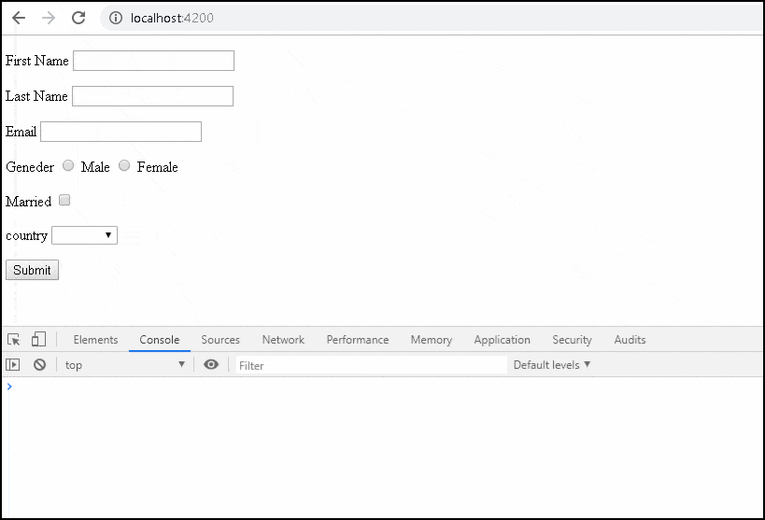Angular template-driven forms in Action

Local Variable
We can assign the ngForm,FormControl or FormGroup instance to a template local variable. This allows us to check the status of the form like whether the form is valid, submitted, and value of the form elements, etc

ngForm
We have access to the ngForm instance via the local template variable #contactForm.
1  2  3 | <form #contactForm="ngForm" (ngSubmit)="onSubmit(contactForm)">
Now, we can make use of some of the properties & methods to know the status of form. For Example
1  2  3  4  5  6  7  8  9  10 | <p>  <button type="submit">Submit</button>  </p>  <pre>Value : {{contactForm.value | json }} </pre>  <pre>Valid : {{contactForm.valid}} </pre>  <pre>Touched : {{contactForm.touched }} </pre>  <pre>Submitted : {{contactForm.submitted }} </pre>
value: The value property returns the object containing the value of every FormControl
valid: Returns true if the form is Valid else returns false.
touched: True if the user has entered a value in at least in one field.
submitted: Returns true if the form is submitted. else false.

FormControl
Similarly, we can also get access to the FormControl instance by assigning the ngModel to a local variable as shown below
1  2  3 | <input type="text" name="firstname" #fname="ngModel" ngModel>
Now, the variable #fname holds the reference to the firstname FormControl. We can then access the properties of FormControl like value, valid, isvalid, tocuhed etc
1  2  3  4  5  6  7  8  9  10  11 | <p>  <label for="firstname">First Name </label>  <input type="text" name="firstname" #fname="ngModel" ngModel>  </p>  <pre>Value : {{fname.value}} </pre>  <pre>valid : {{fname.valid}} </pre>  <pre>invalid : {{fname.invalid}} </pre>  <pre>touched : {{fname.touched}} </pre
value: Returns the current value of the control
valid: Returns true if the value is Valid else false
invalid: True if the value is invalid else false
touched: Returns true if the value is entered in the element

Nested FormGroup
The FormGroup is a collection of FormControl. It can also contain other FormGroup's.
The ngForm directive creates the top Level FormGroup behind the scene, when we use the <Form> directive.
1  2  3 | <form #contactForm="ngForm" (ngSubmit)="onSubmit(contactForm)">
We can add new FormGroup using the ngModelGroup directive. Let us add street, city & Pincode form controls and group them under the address FormGroup
All you need to do is to enclose the fields inside a div element with ngModelGroup directive applied on it as shown below
1  2  3  4  5  6  7  8  9  10  11  12  13  14  15  16  17  18  19 | <div ngModelGroup="address">  <p>  <label for="city">City</label>  <input type="text" name="city" ngModel>  </p>  <p>  <label for="street">Street</label>  <input type="text" name="street" ngModel>  </p>  <p>  <label for="pincode">Pin Code</label>  <input type="text" name="pincode" ngModel>  </p>  </div>
Run the App and submit. The resultant object is as shown below.
1  2  3  4  5  6  7  8  9  10  11  12  13  14  15 | Value : {  "firstname": "Sachin",  "lastname": "Tendulkar",  "email":"sachin@gmail.com"  "gender": "male",  "isMarried": true,  "country": "1",  "address": {  "city": "Mumbai",  "street": "Fashin Street",  "pincode": "400600"  }  }

Setting the Initial Value
The form is usually pre-filled with some default data. In the case of editing, we have to show the user the current data. You can refer to the next tutorial on How to set value in the template-driven form.

Summary
Angular Template-driven Forms is simpler compared to the reactive forms. The FormsModule is imported first. Then we create the HTML form. The Angular detects the <form> tag and converts the form to the Angular Form. ngModel directive added to each form element, which converts them to FormControl. Finally, submit event is subscribed via event binding.

Template-driven Form Validation
Validations in Template-driven forms are provided by the Validation directives. The Angular Forms Module comes with several built-in validators. You can also create your own custom Validator.

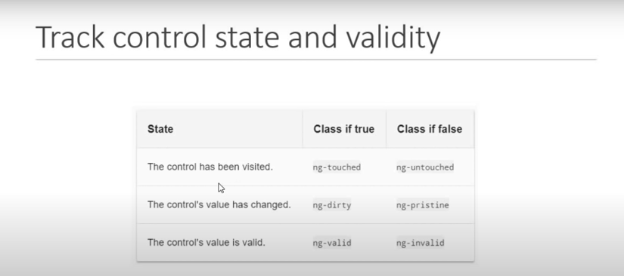

Template
Consider the following template-driven form. It has firstname, lastname, email, gender & istoc form fields.
1  2  3  4  5  6  7  8  9  10  11  12  13  14  15  16  17  18  19  20  21  22  23  24  25  26  27  28  29  30  31  32  33  34  35 | <form #contactForm="ngForm" (ngSubmit)="onSubmit(contactForm)">  <p>  <label for="firstname">First Name </label>  <input type="text" id="firstname" name="firstname" [(ngModel)]="contact.firstname">  </p>  <p>  <label for="lastname">Last Name </label>  <input type="text" id="lastname" name="lastname" [(ngModel)]="contact.lastname">  </p>  <p>  <label for="email">email </label>  <input type="text" id="email" name="email" [(ngModel)]="contact.email">  </p>  <p>  <label for="gender">Geneder </label>  <input type="radio" value="male" id="gender" name="gender" [(ngModel)]="contact.gender"> Male  <input type="radio" value="female" id="gender" name="gender" [(ngModel)]="contact.gender"> Female  </p>  <p>  <label for="isToc">Accept TOC</label>  <input type="checkbox" id="isToc" name="isToc" [(ngModel)]="contact.isToc">  </p>  <p>  <button type="submit">Submit</button>  </p>  </form>

Component Class
1  2  3  4  5  6  7  8  9  10  11  12  13  14  15  16  17  18  19  20  21  22  23  24  25  26  27  28  29  30  31  32  33  34  35  36  37  38  39  40  41  42  43 | import { Component, ViewChild, ElementRef, OnInit } from '@angular/core';  import { NgForm } from '@angular/forms';  @Component({  selector: 'app-root',  templateUrl: './app.component.html',  styleUrls: ['./app.component.css']  })  export class AppComponent implements OnInit {  title = 'Template driven forms';  @ViewChild('contactForm',null) contactForm: NgForm;  contact:contact;  ngOnInit() {  this.contact = {  firstname:"",  lastname:"",  gender:"male",  isToc:true,  email:"",  };  }  onSubmit() {  console.log(this.contactForm.value);  }  }  export class contact {  firstname:string;  lastname:string;  gender:string;  isToc:boolean;  email:string;  }

Disabling the Browser validation
First, we need to disable browser validator interfering with the Angular validator. To do that we need to add novalidate attribute on <form> element as shown below
1  2  3 | <form #contactForm="ngForm" (ngSubmit)="onSubmit(contactForm)" novalidate>

Built-in Validators
The Built-in validators use the HTML5 validation attributes like required, minlength, maxlength & pattern. Angular interprets these validation attributes and add the validator functions to FormControl instance.

Adding in Built-in Validators

Required Validation
The required validator returns true only if the form control has non-empty value entered. Let us add this validator to all fields
1  2  3 | <input type="text" id="firstname" name="firstname" required [(ngModel)]="contact.firstname">

Minlength Validation
This Validator requires the control value must not have less number of characters than the value specified in the validator.
For Example, minlength validator ensures that the firstname value has at least 10 characters.
1  2  3 | <input type="text" id="firstname" name="firstname" required minlength="10" [(ngModel)]="contact.firstname">

Maxlength Validation
This Validator requires that the number of characters must not exceed the value of the attribute.
1  2  3 | <input type="text" id="lastname" name="lastname" required maxlength="15" [(ngModel)]="contact.lastname">

Pattern Validation
This Validator requires that the control value must match the regex pattern provided in the attribute. For example, the pattern ^[a-zA-Z]+$ ensures that the only letters are allowed (even spaces are not allowed). Let us apply this pattern to the lastName
1  2  3  4 | <input type="text" id="lastname" name="lastname" required maxlength="15"  pattern="^[a-zA-Z]+$" [(ngModel)]="contact.lastname">

Email Validation
This Validator requires that the control value must be a valid email address. We apply this to the email field
1  2  3 | <input type="text" id="email" name="email" required email [(ngModel)]="contact.email">

Disable Submit button
Now, we have successfully added the validators. You will notice that the click submit button still submits the form.
We need to disable the submit button if our form is not valid.
Angular forms module keep track of the state of our form and each of its form elements. These states are exposed to the user through FormGroup, FormArray & FormControl objects.
We get the reference to the top-level FormGroup instance by creating a template variable and bind it to ngForm. We have already done it when we had added the #contactForm="ngForm" in our form tag.
The FormGroup has a valid property, which is set to true if all of its child controls are valid. We use it to set the disabled attribute of the submit button.
1  2  3 | <button type="submit" [disabled]="!contactForm.valid">Submit</button>
So long as contactForm.valid remains false, the submit button remains disabled.

Displaying the Validation/Error messages
We need to provide a short and meaningful error message to the user.
Angular creates a FormControl for each and every field, which has ngModel directive applied. The FormControl exposes the state of form element like valid, dirty, touched, etc.
There are two ways in which you can get the reference to the FormControl.
One way is to use the contactForm variable. We can use the contactForm.controls.firstname.valid to find out if the firstname is valid.
The other way is to create a new local variable for each FormControl For Example, the following firstname="ngModel" creates the firstname variable with the FormControl instance.
1  2  3  4 | <input type="text" id="firstname" name="firstname" required minlength="10"  #firstname="ngModel" [(ngModel)]="contact.firstname">
Now, we have a reference to the firstname FormControl instance, we can check its status. We use the valid property to check if the firstname has any errors.
valid: returns either invalid status or null which means a valid status
1  2  3  4  5 | <div *ngIf="!firstname?.valid && (firstname?.dirty || firstname?.touched)">  Invalid First Name  </div>

Why check dirty and touched?
We do not want the application to display the error when the form is displayed for the first time. We want to display errors only after the user has attempted to change the value. The dirty & touched properties help us do that.
dirty: A control is dirty if the user has changed the value in the UI.
touched: A control is touched if the user has triggered a blur event on it.

Error message
The error message ” “Invalid First Name” ” is not helpful. The firstname has two validators. required and minlength
Any errors generated by the failing validation is updated in the errors object. The errors object returns the error object or null if there are no errors.
1  2  3  4  5  6  7  8  9  10  11 | <div *ngIf="!firstname?.valid && (firstname?.dirty || firstname?.touched)">  Invalid First Name  <div *ngIf="firstname.errors.required">  First Name is required  </div>  <div *ngIf="firstname.errors.minlength">  First Name Minimum Length is {{firstname.errors.minlength?.requiredLength}}  </div>  </div>
Note that the minlength validators return the {{firstname.errors.minlength?.requiredLength}}, which we use the display the error message.

Final Template
1  2  3  4  5  6  7  8  9  10  11  12  13  14  15  16  17  18  19  20  21  22  23  24  25  26  27  28  29  30  31  32  33  34  35  36  37  38  39  40  41  42  43  44  45  46  47  48  49  50  51  52  53  54  55  56  57  58  59  60  61  62  63  64  65  66  67  68  69  70  71  72  73  74  75  76  77  78  79  80  81 | <form #contactForm="ngForm" (ngSubmit)="onSubmit(contactForm)" novalidate>  <p>  <label for="firstname">First Name </label>  <input type="text" id="firstname" name="firstname" required minlength="10" #firstname="ngModel"  [(ngModel)]="contact.firstname">  </p>  <div *ngIf="!firstname?.valid && (firstname?.dirty || firstname?.touched)" class="error">  <div *ngIf="firstname.errors.required">  First Name is required  </div>  <div *ngIf="firstname.errors.minlength">  First Name Minimum Length is {{firstname.errors.minlength?.requiredLength}}  </div>  </div>  <p>  <label for="lastname">Last Name </label>  <input type="text" id="lastname" name="lastname" required maxlength="15" #lastname="ngModel"  pattern="^[a-zA-Z]+$" [(ngModel)]="contact.lastname">  </p>  <div *ngIf="!lastname?.valid && (lastname?.dirty || lastname?.touched)" class="error">  <div *ngIf="lastname.errors.required">  Last Name is required  </div>  <div *ngIf="lastname.errors.maxlength">  Last Name Minimum Length is {{lastname.errors.maxlength?.requiredLength}}  </div>  <div *ngIf="lastname.errors.pattern">  Only characters are allowed  </div>  </div>  <p>  <label for="email">email </label>  <input type="text" id="email" name="email" required email #email="ngModel" [(ngModel)]="contact.email">  </p>  <div *ngIf="!email?.valid && (email?.dirty || email?.touched)" class="error">  <div *ngIf="email.errors.required">  Email is required  </div>  <div *ngIf="email.errors.email">  Invalid Email Address  </div>  </div>  <p>  <label for="gender">Geneder </label>  <input type="radio" value="male" id="gender" name="gender" #gender="ngModel" required [(ngModel)]="contact.gender">  Male  <input type="radio" value="female" id="gender" name="gender" #gender="ngModel" required  [(ngModel)]="contact.gender"> Female  </p>  <div *ngIf="!gender?.valid && (gender?.dirty || gender?.touched)" class="error">  <div *ngIf="gender.errors.required">  Gender is required  </div>  </div>  <p>  <label for="isToc">Accept TOC</label>  <input type="checkbox" id="isToc" name="isToc" required #isToc="ngModel" [(ngModel)]="contact.isToc">  </p>  <div *ngIf="!isToc?.valid && (isToc?.dirty || isToc?.touched)" class="error">  <div *ngIf="isToc.errors.required">  Please accept the TOC  </div>  </div>  <p>  <button type="submit" [disabled]="!contactForm.valid">Submit</button>  </p>  <p>{{contactForm.valid}} </p>  </form>

Summary
Angular template-driven form validation uses the directives known as validators. The validators handle form validations and display validation messages. The Angular comes up with several built-in validators for this purpose. They are minlength, maxlength, email, pattern, required, etc.

What are Reactive Forms?
Reactive forms are forms where we define the structure of the form in the component class. I,e we create the form model with Form Groups, Form Controls, and Form Arrays. We also define the validation rules in the component class. Then, we bind it to the HTML form in the template. This is different from the template-driven forms, where we define the logic and controls in the HTML template.

How to use Reactive Forms
- Import ReactiveFormsModule
- Create Form Model in component class using Form Group, Form Control & Form Arrays
- Create the HTML Form resembling the Form Model.
- Bind the HTML Form to the Form Model

Reactive Forms Example Application
Use ng new to create a new application
1  2  3 | ng new mdf --routing=true --style=css
Run ng serve and verify if everything is installed correctly.

Import ReactiveFormsModule
To work with Reactive forms, we must import the ReactiveFormsModule. We usually import it in root module or in a shared module. The ReactiveFormsModule contains all the form directives and constructs for working with angular reactive forms.
1  2  3  4  5  6  7  8  9  10  11  12  13  14  15  16  17  18  19  20  21  22 | import { BrowserModule } from '@angular/platform-browser';  import { NgModule } from '@angular/core';  import { ReactiveFormsModule } from '@angular/forms';  import { AppRoutingModule } from './app-routing.module';  import { AppComponent } from './app.component';  @NgModule({  declarations: [  AppComponent  ],  imports: [  BrowserModule,  AppRoutingModule,  ReactiveFormsModule  ],  providers: [],  bootstrap: [AppComponent]  })  export class AppModule { }

Model
In the template-driven approach, we used ngModel & ngModelGroup directive on the HTML elements. The FormsModule created the FormGroup & FormControl instances from the template. This happens behind the scene.

In Reactive Forms approach, It is our responsibility to build the Model using FormGroup, FormControl and FormArray.
The FormGroup, FormControl & FormArray are the three building blocks of the Angular Forms.

FormControl encapsulates the state of a single form element in our form. It stores the value and state of the form element and helps us to interact with them using properties & methods.
FormGroup represents a collection of form Controls. It can also contain form groups and form arrays. In fact, an angular form is a FormGroup.
Let’s create the model for our Form.
First, we need to import FormGroup, FormControl & Validator from the @angular/forms. Open the app.component.ts and the add following import statement.
1  2  3 | import { FormGroup, FormControl, Validators } from '@angular/forms'

FormGroup
The FormGroup is created with the following syntax
1  2  3 | contactForm = new FormGroup({})
The FormGroup takes 3 arguments. a collection of a child FormControl, a validator, and an asynchronous validator. The validators are optional.

FormControl
The first argument to FormGroup is the collection of FormControl. They are added using the FormControl method as shown below
1  2  3  4  5  6  7  8  9  10 | contactForm = new FormGroup({  firstname: new FormControl(),  lastname: new FormControl(),  email: new FormControl(),  gender: new FormControl(),  isMarried: new FormControl(),  country: new FormControl()  })
In the above, we have created an instance of a FormGroup and named it as contactForm. contactForm is our top-level FormGroup. Under the contactForm, we have five FormControl instances each representing the properties firstname. lastname.email, gender, ismarried & country.
The Other two arguments to FormGroup are Sync Validator & Async Validator. They are optional.

HTML Form
The next task is to build an HTML form. The following is a regular HTML form. We enclose it in a <form> tag. We have included two text input (FirstName & LastName), an email field, a radio button (gender), a checkbox (isMarried), and a select list (country). These are Form elements.
1  2  3  4  5  6  7  8  9  10  11  12  13  14  15  16  17  18  19  20  21  22  23  24  25  26  27  28  29  30  31  32  33  34  35  36  37  38  39  40  41  42  43  44 | <form">  <p>  <label for="firstname">First Name </label>  <input type="text" id="firstname" name="firstname">  </p>  <p>  <label for="lastname">Last Name </label>  <input type="text" id="lastname" name="lastname">  </p>  <p>  <label for="email">Email </label>  <input type="text" id="email" name="email">  </p>  <p>  <label for="gender">Gender </label>  <input type="radio" value="male" id="gender" name="gender"> Male  <input type="radio" value="female" id="gender" name="gender"> Female  </p>  <p>  <label for="isMarried">Married </label>  <input type="checkbox" id="isMarried" name="isMarried">  </p>  <p>  <label for="country">country </label>  <select id="country" name="country">  <option [ngValue]="c.id" *ngFor="let c of countryList">  {{c.name}}  </option>  </select>  </p>  <p>  <button type="submit">Submit</button>  </p>  </form>

Binding the template to the model
Now we need to associate our model to the Template. We need to tell angular that we have a model for the form.
This is done using the formGroup directive as shown below.
1  2  3 | <form [formGroup]="contactForm">
We have used the square bracket (one-way binding) around FormGroup directive and set that equal the model.
Next, we need to bind form fields to the FormControl models. We use the FormControlName directive for this. We add this directive to every form field element in our form. The value is set to the name of the corresponding FormControl instance in the component class.
1  2  3  4 | <input type="text" id="firstname" name="firstname" formControlName="firstname">  <input type="text" id="lastname" name="lastname" formControlName="lastname">

Submit form
We submit the form data to the component using the Angular directive named ngSubmit. Note that we already have a submit button in our form. The ngSubmit directive binds itself to the click event of the submit button. We are using event binding (parentheses) to bind ngSubmit to OnSubmit method. When the user clicks on the submit button ngSubmit invokes the OnSubmit method on the Component class
1  2  3 | <form [formGroup]="contactForm" (ngSubmit)="onSubmit()">

Final Template
Our Final Template is as shown below
1  2  3  4  5  6  7  8  9  10  11  12  13  14  15  16  17  18  19  20  21  22  23  24  25  26  27  28  29  30  31  32  33  34  35  36  37  38  39  40  41  42  43  44 | <form [formGroup]="contactForm" (ngSubmit)="onSubmit()">  <p>  <label for="firstname">First Name </label>  <input type="text" id="firstname" name="firstname" formControlName="firstname">  </p>  <p>  <label for="lastname">Last Name </label>  <input type="text" id="lastname" name="lastname" formControlName="lastname">  </p>  <p>  <label for="email">Email </label>  <input type="text" id="email" name="email" formControlName="email">  </p>  <p>  <label for="gender">Geneder </label>  <input type="radio" value="male" id="gender" name="gender" formControlName="gender"> Male  <input type="radio" value="female" id="gender" name="gender" formControlName="gender"> Female  </p>  <p>  <label for="isMarried">Married </label>  <input type="checkbox" id="isMarried" name="isMarried" formControlName="isMarried">  </p>  <p>  <label for="country">country </label>  <select id="country" name="country" formControlName="country">  <option [ngValue]="c.id" *ngFor="let c of countryList">  {{c.name}}  </option>  </select>  </p>  <p>  <button type="submit">Submit</button>  </p>  </form>

Receive the data in the Component class
The last step is to receive the form data in the component class. All we need to do is to create the onSubmit method in our component class.
1  2  3  4  5 | onSubmit() {  console.log(this.contactForm.value);  }
We are using the console.log(this.contactForm.value) to send the value of our form data to the console window.

Test the form
Now you can run the app and see the result. Open the developer console and see the value returned by the contactForm.value. The values of the form are returned as JSON object as shown below, which you can pass it your backend API to persist the information to the database.

FormControl
A FormControl takes 3 arguments. a default value, a validator and an asynchronous validator. All of them are optional.

Default Value
You can pass a default value as either as a string or as an object of key-value pair. When you pass object you can set both the value and the whether or not the control is disabled.
1  2  3  4 | //Setting Default value as string  firstname= new FormControl(‘Sachin’);

1  2  3  4 | //Setting Default value & disabled state as object  firstname: new FormControl({value: ‘Rahul’, disabled: true}),

Sync Validator
The second parameter is an array of sync Validators. Angular has some built-in Validators such as required and minLength etc.
You can pass with Validator function as shown below.
1  2  3 | firstname: new FormControl('', [Validators.required,Validators.minLength(10)]),

Asynchronous validator
The third argument is the Async Validator. The syntax of Async Validators is similar to Sync Validators.
More on validation in our next tutorial Validations in Reactive forms.

Grouping the controls using FormGroup
We can group various form controls together. For Example fields such as street, city, and Pincode each will have their own form control, but can be grouped together as an address form group
1  2  3  4  5  6  7  8  9  10  11  12  13  14  15 | contactForm = new FormGroup({  firstname: new FormControl(),  lastname: new FormControl(),  email: new FormControl(),  gender: new FormControl(),  isMarried: new FormControl(),  country: new FormControl(),  address:new FormGroup({  city: new FormControl(),  street: new FormControl(),  pincode:new FormControl()  })  })
In the code above, we have created new FormGroup Address and added three form controls i.e city, street & Pincode
In the template use the formGroupName directive to enclose the control using a div element as shown below
1  2  3  4  5  6  7  8  9  10  11  12  13  14  15  16  17  18  19  20 | <div formGroupName="address">  <div class="form-group">  <label for="city">City</label>  <input type="text" class="form-control" name="city" formControlName="city" >  </div>  <div class="form-group">  <label for="street">Street</label>  <input type="text" class="form-control" name="street" formControlName="street" >  </div>  <div class="form-group">  <label for="pincode">Pin Code</label>  <input type="text" class="form-control" name="pincode" formControlName="pincode">  </div>  </div>

Validators in Reactive Forms

What is a Validator
A Validator is a function that checks the instance of FormControl, FormGroup or a FormArray and returns a list of errors. If the Validator returns a null means that validation has passed

How to add a Validator to Reactive Forms
We configure the validators as the second and third argument to the FormControl, FormGroup or FormArray in the component class. The second argument is a collection of sync validators and the third argument is a collection of an async validators.
sync validators runs validations and returns immediately. They either return a list of errors or null if no errors found.
async validators: returns a Promise or Observable. They either return a list of errors or null if no errors are found.

Built-in Validators
The Angular ReactiveForms Module provides several Built-in validators out of the box. They are required, minlength, maxlength & pattern etc.

Reactive Forms Validation Example
W learned how to create Angular Reactive Forms in the previous tutorial. We will now add some of the built-in validators to that example.

Model
Here is the contactForm model from the previous tutorial.
1  2  3  4  5  6  7  8  9  10  11  12  13  14  15 | contactForm = new FormGroup({  firstname: new FormControl(''),  lastname: new FormControl(''),  email:new FormControl(''),  gender: new FormControl(''),  isMarried: new FormControl(''),  country: new FormControl(''),  address:new FormGroup({  city: new FormControl(''),  street: new FormControl(''),  pincode:new FormControl('')  })  })

Disabling the Browser validation
First, we need to disable browser validator by adding the novalidate attribute to the <form> element as shown below. If this attribute is present then the form is not validated by the built-in HTML5 validation when submitted.
1  2  3 | <form [formGroup]="contactForm" (ngSubmit)="onSubmit()" novalidate>

Adding in Built-in Validators
The mentioned earlier, the Angular has provided several built-in validators out of the box.

Required Validator
The required validator is a sync validator, which returns true only if the formcontrol has a non-empty value entered. The second argument of the FormControl takes the Sync Validator.
1  2  3 | firstname: new FormControl('',[Validators.required]),

Minlength Validator
Minlength validator requires the control value must not have less number of characters than the value specified in the validator.
For Example, minlength validator ensures that the firstname value has at least 10 characters.
1  2  3 | firstname: new FormControl('',[Validators.required,Validators.minLength(10)]),

Maxlength Validator
This Validator requires that the number of characters must not exceed the value specified in the validator.
1  2  3 | lastname: new FormControl('',[Validators.maxLength(15)]),

Pattern Validator
This Validator requires that the control value must match the regex pattern provided in the attribute. For example, the pattern ^[a-zA-Z]+$ ensures that the only letters are allowed (even spaces are not allowed). Let us apply this pattern to the lastName
1  2  3 | lastname: new FormControl('',[Validators.maxLength(15), Validators.pattern("^[a-zA-Z]+$")]),

Email Validator
This Validator requires that the control value must be a valid email address. We apply this to the email field
1  2  3 | email:new FormControl('',[Validators.email,Validators.required]),
After adding all the validators, our final contactForm will look like this.
1  2  3  4  5  6  7  8  9  10  11  12  13  14  15 | contactForm = new FormGroup({  firstname: new FormControl('',[Validators.required,Validators.minLength(10)]),  lastname: new FormControl('',[Validators.required, Validators.maxLength(15), Validators.pattern("^[a-zA-Z]+$")]),  email:new FormControl('',[Validators.email,Validators.required]),  gender: new FormControl('',[Validators.required]),  isMarried: new FormControl('',[Validators.required]),  country: new FormControl('',[Validators.required]),  address:new FormGroup({  city: new FormControl('',[Validators.required]),  street: new FormControl('',[Validators.required]),  pincode:new FormControl('',[Validators.required])  })  })

Disable Submit button
We have successfully added the validators. Now, we need to disable the submit button if our form is not valid.
The Angular Forms API exposes the state of the forms through the FormGroup, FormControl & FormArray instances. The FormGroup control has a property valid, which is set to true if all of its child controls are valid.
The contactForm represents the top-level FormGroup. We use it to set the disabled attribute of the submit button.
1  2  3 | <button type="submit" [disabled]="!contactForm.valid">Submit</button>

Displaying the Validation/Error

messages
We need to provide a short and meaningful error message to the user. We do that by using the error object returned by the FormControl instance
Every form element has a FormControl instance associated with it. It exposes the state of form element like valid, dirty, touched etc.
There are two ways in which you can get the reference to the FormControl.
One way is to use the contactForm variable. We can use contactForm.controls.firstname.valid to find out if the firstname is valid.
1  2  3  4  5  6  7 | <div  *ngIf="!contactForm.controls.firstname?.valid && (contactForm.controls.firstname?.dirty  ||contactForm.controls.firstname?.touched)">  First Name is not valid  </div>
The other way to is to define getter function for each FormControl instance in the component class.
1  2  3  4  5 | get firstname() {  return this.contactForm.get('firstname');  }
and then use it in the template as follows
1  2  3  4  5 | <div *ngIf="!firstname.valid && (firstname.dirty ||firstname.touched)">  First Name is not valid  </div>

Dirty & touched
Apart from checking valid we are also checking for the dirty & touched. Because we do not want the application to display the error when the form is displayed for the first time. We want to display errors only after the user has attempted to change the value. The dirty & touched properties help us do that.
dirty: A control is dirty if the user has changed the value in the UI.
touched: A control is touched if the user has triggered a blur event on it.

Error message
The error message “First Name is not valid ” is not helpful. The firstname has two validators. required and minlength
Any errors generated by the failing validation is updated in the errors object. The errors object returns the error object or null if there are no errors.
1  2  3  4  5  6  7  8  9  10  11 | <div  *ngIf="!firstname?.valid && (firstname?.dirty ||firstname?.touched)">  <div [hidden]="!firstname.errors.required">  First Name is required  </div>  <div [hidden]="!firstname.errors.minlength">  Min Length is 10  </div>  </div>

Final Code
app.component.ts
1  2  3  4  5  6  7  8  9  10  11  12  13  14  15  16  17  18  19  20  21  22  23  24  25  26  27  28  29  30  31  32  33  34  35  36  37  38  39  40  41  42  43  44  45  46  47  48  49  50  51  52  53  54  55  56  57  58  59  60  61  62  63  64  65  66  67  68  69  70  71  72  73  74  75  76  77  78  79  80  81  82  83  84  85  86  87  88  89  90  91  92  93  94  95  96  97  98  99  100  101  102  103  104  105  106  107  108  109 | import { Component, ViewChild, ElementRef } from '@angular/core';  import { FormGroup, FormControl, Validators } from '@angular/forms'  @Component({  selector: 'app-root',  templateUrl: './app.component.html',  styleUrls: ['./app.component.css']  })  export class AppComponent {  title = 'Angular Reactive forms';  contactForm = new FormGroup({  firstname: new FormControl('',[Validators.required,Validators.minLength(10)]),  lastname: new FormControl('',[Validators.required, Validators.maxLength(15), Validators.pattern("^[a-zA-Z]+$")]),  email:new FormControl('',[Validators.email,Validators.required]),  gender: new FormControl('',[Validators.required]),  isMarried: new FormControl('',[Validators.required]),  country: new FormControl('',[Validators.required]),  address:new FormGroup({  city: new FormControl('',[Validators.required]),  street: new FormControl('',[Validators.required]),  pincode:new FormControl('',[Validators.required])  })  })  get firstname() {  return this.contactForm.get('firstname');  }  get lastname() {  return this.contactForm.get('lastname');  }  get email() {  return this.contactForm.get('email');  }  get gender() {  return this.contactForm.get('gender');  }  get isMarried() {  return this.contactForm.get('isMarried');  }  get country() {  return this.contactForm.get('country');  }  get city() {  return this.contactForm.get("address").get('city');  }  get street() {  return this.contactForm.get("address").get('street');  }  get pincode() {  return this.contactForm.get("address").get('pincode');  }  countryList: country[] = [  new country("1", "India"),  new country('2', 'USA'),  new country('3', 'England')  ];  onSubmit() {  console.log(this.contactForm.value);  }  }  export class contact {  firstname:string;  lastname:string;  gender:string;  isMarried:boolean;  country:string;  address: {  city:string;  street:string;  pincode:string;  }  }  export class country {  id: string;  name: string;  constructor(id: string, name: string) {  this.id = id;  this.name = name;  }  }
app.component.html
1  2  3  4  5  6  7  8  9  10  11  12  13  14  15  16  17  18  19  20  21  22  23  24  25  26  27  28  29  30  31  32  33  34  35  36  37  38  39  40  41  42  43  44  45  46  47  48  49  50  51  52  53  54  55  56  57  58  59  60  61  62  63  64  65  66  67  68  69  70  71  72  73  74  75  76  77  78  79  80  81  82  83  84  85  86  87  88  89  90  91  92  93  94  95  96  97  98  99  100  101  102  103  104  105  106  107  108  109  110  111  112  113  114  115  116  117  118  119  120  121  122  123  124  125  126  127  128  129  130  131  132  133  134  135  136  137  138  139  140  141  142  143  144  145  146  147  148  149  150  151  152 | <form [formGroup]="contactForm" (ngSubmit)="onSubmit()" novalidate>  <p>  <label for="firstname">First Name </label>  <input type="text" id="firstname" name="firstname" formControlName="firstname">  </p>  <div  *ngIf="!firstname?.valid && (firstname?.dirty ||firstname?.touched)">  <div [hidden]="!firstname.errors.required">  First Name is required  </div>  <div [hidden]="!firstname.errors.minlength">  Min Length is 10  </div>  </div>  <p>  <label for="lastname">Last Name </label>  <input type="text" id="lastname" name="lastname" formControlName="lastname">  </p>  <div *ngIf="!lastname.valid && (lastname.dirty ||lastname.touched)">  <div [hidden]="!lastname.errors.pattern">  Only characters are allowed  </div>  <div [hidden]="!lastname.errors.maxLength">  Max length allowed is {{lastname.errors.maxlength?.requiredLength}}  </div>  <div [hidden]="!lastname.errors.required">  Last Name is required  </div>  </div>  <p>  <label for="email">Email </label>  <input type="text" id="email" name="email" formControlName="email">  </p>  <div *ngIf="!email.valid && (email.dirty ||email.touched)">  <div [hidden]="!email.errors.required">  email is required  </div>  <div [hidden]="!email.errors.email">  invalid email id  </div>  </div>  <p>  <label for="gender">Geneder </label>  <input type="radio" value="male" id="gender" name="gender" formControlName="gender"> Male  <input type="radio" value="female" id="gender" name="gender" formControlName="gender"> Female  </p>  <div *ngIf="!gender.valid && (gender.dirty ||gender.touched)">  <div [hidden]="!gender.errors.required">  gender is required  </div>  </div>  <p>  <label for="isMarried">Married </label>  <input type="checkbox" id="isMarried" name="isMarried" formControlName="isMarried">  </p>  <div *ngIf="!isMarried.valid && (isMarried.dirty ||isMarried.touched)">  <div [hidden]="!isMarried.errors.required">  isMarried is required  </div>  </div>  <p>  <label for="country">country </label>  <select id="country" name="country" formControlName="country">  <option [ngValue]="c.id" *ngFor="let c of countryList">  {{c.name}}  </option>  </select>  </p>  <div *ngIf="!country.valid && (country.dirty ||country.touched)">  <div [hidden]="!country.errors.required">  country is required  </div>  </div>  <div formGroupName="address">  <div class="form-group">  <label for="city">City</label>  <input type="text" class="form-control" name="city" formControlName="city">  </div>  <div *ngIf="!city.valid && (city.dirty ||city.touched)">  <div [hidden]="!city.errors.required">  city is required  </div>  </div>  <div class="form-group">  <label for="street">Street</label>  <input type="text" class="form-control" name="street" formControlName="street">  </div>  <div *ngIf="!street.valid && (street.dirty ||street.touched)">  <div [hidden]="!street.errors.required">  street is required  </div>  </div>  <div class="form-group">  <label for="pincode">Pin Code</label>  <input type="text" class="form-control" name="pincode" formControlName="pincode">  </div>  <div *ngIf="!pincode.valid && (pincode.dirty ||pincode.touched)">  <div [hidden]="!pincode.errors.required">  pincode is required  </div>  </div>  </div>  <p>{{contactForm.valid}} </p>  <p>  <button type="submit" [disabled]="!contactForm.valid">Submit</button>  </p>  </form>  <!-- <div ngModelGroup="address">  <p>  <label for="city">City</label>  <input type="text" id="city" name="city">  </p>  <p>  <label for="street">Street</label>  <input type="text" id="street" name="street">  </p>  <p>  <label for="pincode">Pin Code</label>  <input type="text" id="pincode" name="pincode">  </p>  </div> -->

Angular Routing:

Single page application (SPA)
A single-page application (SPA) is an approach in which we create a website design where each new page is not served from the server but generated dynamically through JavaScript's ability to manipulate the DOM elements on the existing page itself.

Routing
Considering you have the basic knowledge on Angular, I believe you know that Angular helps to create UI as the combination of compatible and reusable web components. So, when we say navigation in an Angular application, it simply means navigating between those components. It can be achieved by implementing routing.
Routing is a simple mechanism in a web application by which the requests are routed to the code that handles them. A framework is instructed with the help of some code for what code to be executed when a request is received with some URL.
In Angular, routing can be achieved using an Angular module called “RouterModule”. It is defined inside “@angular/router”.
Case 1: url: localhost/login Case 2: localhost/home
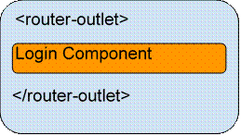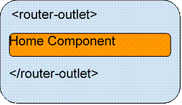

The Router Outlet

The Router-Outlet is a directive exported by RouterModule and acts as a placeholder that indicates the router where it needs to insert the matched component.

The Navigation Directive
The Angular Router provides two directives for navigation. The routerLink directive replaces the href attribute of anchor(<a>) tags to create links and routerLinkActive is used for making the active link.
For example.
- <a [routerLink]="/products" [routerLinkActive]="/products">Products</a>
Note
Please note that Routing has nothing to do with menus. It is simply about URL and code to be executed. To a framework, how the request is made is not countable.
Let us create a sample TestApp. For this you should have installed the below for the development environment,
- Node
- Npm (comes when you install node)
- Angular CLi.
- Text Editor.
For creating a new application run the below command on your location.
> ng new TestApp
Once your command is completed you will have TestApp folder created inside your sample folder.
Now you will have your project folder called 'TestApp'.
Note
See my previous article “Getting started with Angular CLI.” If you want the installation and introduction from the basics and start with execution of the sample application.
Let us start by creating a simple application having two components with a link for both views in the home page index.html, and make the navigation possible on their clicks, respectively.
Let us create two components,
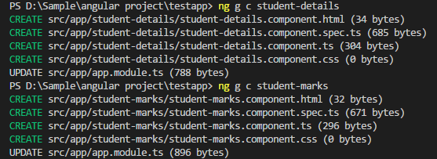
We will have two views,
- Localhost:4200/studentDetails
- Localhost:4200/studentMarks

Inside app folder add routing file app-routing.module.ts and add the below contents,
- import { NgModule } from '@angular/core';
- import { Routes, RouterModule } from '@angular/router';
- import { StudentDetailsComponent } from './student-details/student-details.component';
- import { StudentMarksComponent } from './student-marks/student-marks.component';

- const routes:Routes = [
- {path:'studentDetails', component : StudentDetailsComponent},
- {path:'studentMarks', component : StudentMarksComponent}
- ];

- @NgModule({
- imports : [RouterModule.forRoot(routes)],
- exports: [RouterModule]
- })
- export class AppRoutingModule{}
Open app.component.html and add the below contents,
- <!--The content below is only a placeholder and can be replaced.-->
- <div style="text-align:center">
- <h1>
- Welcome to {{ title }}!
- </h1>
- </div>
- <ul>
- <li>
- <a routerLink="/studentDetails">Student Details</a>
- </li>
- <li>
- <a routerLink="/studentMarks">Student Marks</a>
- </li>
- </ul>
- <router-outlet></router-outlet>
Open student-details.component.html and add the below contents,
- <h2>Student Details</h2>
- <p>This is student details page. You can fetch the details of students through services and render here in this view.</p>
Open student-marks.component.html and add the below contents,
- <h2>Marks Details</h2>
- <p>This is student marks details page. you can perform the fetching of stuedent marks and render here in this view through services.</p>
Now import AppRoutingModule in AppModule.
Open app.module.ts and add the below contents,
- import { BrowserModule } from '@angular/platform-browser';
- import { NgModule } from '@angular/core';
- import {FormsModule} from '@angular/forms';
- import { AppComponent } from './app.component';
- import { StudentDetailsComponent } from './student-details/student-details.component';
- import { StudentMarksComponent } from './student-marks/student-marks.component';
- import { AppRoutingModule } from './app-routing.module';

- @NgModule({
- declarations: [
- AppComponent,
- StudentDetailsComponent,
- StudentMarksComponent
- ],
- imports: [
- BrowserModule,
- AppRoutingModule
- ],
- providers: [],
- bootstrap: [AppComponent]
- })
- export class AppModule { }
Run the application,
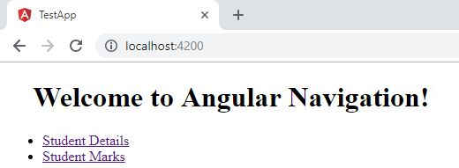
See the url ‘localhost:4200’
Click on student Details.
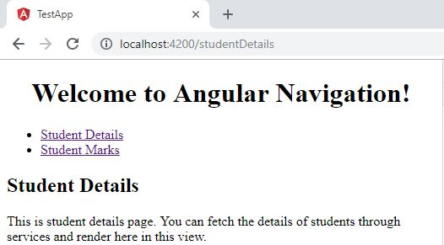
See the url ‘localhost:4200/studentDetails’
Click on student marks.
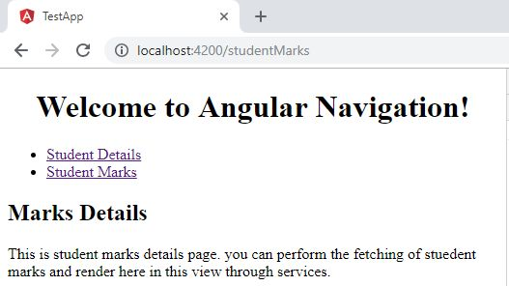
Url is now ‘localhost:4200/studentMarks
So now we are done with the sample navigation using routing in angular.
What we have done:
- In Index.html we should have ‘<base href=”/”>’
- In app-routing module configures the routes. Each path will have a path and corresponding component.
- After defining routes pass the routes to the RouterModule.
- Export the AppRoutingModule.
- Import AppRoutingModule in appModule and include it in the imports array.
- To navigate we have links with ‘routerLink’ directive with a path.
- Click to navigate between views.

Build an Angular 9/8 CRUD Example & Tutorial
We'll be using a CRUD REST API mocked using json-server which lets you generate a complete working API with nearly zero-lines of code.
We'll not be learning how to use json-server but you can see the complete instructions from this tutorial after generating the Angular project.
- Step 1 — Mocking the Backend Using json-server
- Step 2 — Creating an Angular 9 Module
- Step 3 — Importing Angular HttpClientModule and FormsModule
- Step 4 — Creating Angular Component(s)
- Step 5 — Adding Angular Routing
- Step 6 — Creating an Angular Service
- Step 7 — Creating a Model
- Step 8 — Implementing the CRUD Methods
- Step 9 — Calling the CRUD Methods

Prerequisites
As always, we'll need to have a few prerequisites for this tutorial:
- The basic concepts of TypeScript.
- A local development machine with Node 10+, together with NPM installed.
- Angular CLI 9 installed on your machine,
- An Angular project. In our case, it's named angular-crud-example.
If your project is ready, let's get started with our first step.

Angular CRUD Example, Step 1 — Mocking the Backend Using json-server
We have already covered how to mock the REST API in Mocking a REST API Back-End for Your Angular App with JSON-Server and Faker.js
You can simply follow the linked tutorial to quickly build a server that will be running from the http://localhost:3000 address and exposing the following endpoints:
- GET /products for getting the products,
- GET /products/<id> for getting a single product by id,
- POST /products for creating a new product,
- PUT /products/<id> for updating a product by id,
- PATCH /products/<id> for partially updating a product by id,
- DELETE /products/<id> for deleting a product by id.

Step 2 — Creating an Angular 9 Module
We'll encapsulate the code for our CRUD interface inside a module called crud. Open a new command-line interface and generate a module using the following command:
$ cd ~/angular-crud-example
$ ng generate module crud --routing
This will create a src/app/crud/crud.module.ts file with the following code:
import { NgModule } from '@angular/core';
import { CommonModule } from '@angular/common';

import { CrudRoutingModule } from './crud-routing.module';

@NgModule({
declarations: [],
imports: [
CommonModule,
CrudRoutingModule
]
})
export class CrudModule { }

Step 3 — Importing Angular 9 HttpClientModule and FormsModule
In this step, we'll proceed to add HttpClientModule and FormsModule in our project so we can use HttpClient and forms to implement the CRUD operations against the API server.
Open the src/app/crud/crud.module.ts file and add HttpClientModuleand FormsModuleto the imports array of the module as follows:
import { NgModule } from '@angular/core';
import { CommonModule } from '@angular/common';
import { HttpClientModule } from '@angular/common/http';
import { FormsModule } from '@angular/forms';

import { CrudRoutingModule } from './crud-routing.module';

@NgModule({
declarations: [],
imports: [
CommonModule,
CrudRoutingModule,
HttpClientModule,
FormsModule
]
})
export class CrudModule { }

Step 4 — Creating Angular 9 Component(s)
In this step, we'll create the Angular components. that compose the UI of our CRUD application:
- A home component that renders a table of products and contains the CRUD operations,
- A details component that displays the details of a specific product,
- A create component for creating products,
- A update component for updating products.
Open a new command-line interface and run the following commands:
$ ng generate component crud/home
$ ng generate component crud/details
$ ng generate component crud/create
$ ng generate component crud/update
The CLI will create the necessary files for the components and add them to the declarations array in the src/app/crud/crud.module.ts file:
import { NgModule } from '@angular/core';
import { CommonModule } from '@angular/common';
import { HttpClientModule } from '@angular/common/http';

import { CrudRoutingModule } from './crud-routing.module';
import { HomeComponent } from './home/home.component';
import { DetailsComponent } from './details/details.component';
import { CreateComponent } from './create/create.component';
import { UpdateComponent } from './update/update.component';

@NgModule({
declarations: [HomeComponent, DetailsComponent, CreateComponent, UpdateComponent],
imports: [
CommonModule,
CrudRoutingModule,
HttpClientModule
]
})
export class CrudModule { }

Step 5 — Adding Angular 9 Routing
In this step, we'll add routing. to our CRUD module.
Head back to the src/app/crud/crud-routing.module.ts file, that was automatically created by Angular CLI for routing configuration, and import the components then add the routes as follows:
import { NgModule } from '@angular/core';
import { Routes, RouterModule } from '@angular/router';
import { HomeComponent } from './home/home.component';
import { DetailsComponent } from './details/details.component';
import { CreateComponent } from './create/create.component';
import { UpdateComponent } from './update/update.component';

const routes: Routes = [
{ path: 'crud', redirectTo: 'crud/home', pathMatch: 'full'},
{ path: 'crud/home', component: HomeComponent },
{ path: 'crud/details/:productId', component: DetailsComponent },
{ path: 'crud/create', component: CreateComponent },
{ path: 'crud/update/:productId', component: UpdateComponent }
];

@NgModule({
imports: [RouterModule.forRoot(routes)],
exports: [RouterModule]
})
export class AppRoutingModule { }

We first imported the CRUD components, next we added five routes for each component and a redirection route which simply redirects users to the home component when they visit the empty path.
In the next step of our example, we'll a service for crud methods.

Step 6 — Creating an Angular 9 Service
In this step, we'll create an an Angular service that encapsulates the CRUD operations and make them available to the various UI components.
Go back to your command-line interface and run the following command:
$ ng generate service crud/crud
Next, open the src/app/crud/crud.service.ts file, and import and inject HttpClient as follows:
import { Injectable } from '@angular/core';
import { HttpClient } from '@angular/common/http';

@Injectable({
providedIn: 'root'
})
export class CrudService {

private apiServer = "http://localhost:3000";

constructor(private httpClient: HttpClient) { }
}
We imported and injected the HttpClient service. We also defined the apiServer variable that contains the address of our REST API server.

Step 7 — Creating an Angular 9 Model
In this step, we'll see how to create a model for using typed HTTP responses in our example.
Head back to your command-line interface and run the following command from the root of your project:
$ ng generate interface crud/product
Next, open the src/app/crud/product.ts file and update it as follows:
export interface Product {
id: number;
name: string;
description: string;
price: number;
quantity: number;
}

Step 8 — Implementing the CRUD Methods
Let's now implement the CRUD operations for creating, reading. updating and deleting products using a service.
Open the src/app/crud/crud.service.ts file and update it as follows:
import { Injectable } from '@angular/core';
import { HttpClient, HttpErrorResponse } from "@angular/common/http";

import { throwError } from 'rxjs';
import { catchError } from 'rxjs/operators';

import { Product } from './product';

@Injectable({
providedIn: 'root'
})
export class CrudService {

private apiServer = "http://localhost:3000";
httpOptions = {
headers: new HttpHeaders({
'Content-Type': 'application/json'
})
}
constructor(private httpClient: HttpClient) { }

create(product): Observable<Product> {
return this.httpClient.post<Product>(this.apiServer + '/products/', JSON.stringify(product), this.httpOptions)
.pipe(
catchError(this.errorHandler)
)
}
getById(id): Observable<Product> {
return this.httpClient.get<Product>(this.apiServer + '/products/' + id)
.pipe(
catchError(this.errorHandler)
)
}

getAll(): Observable<Product[]> {
return this.httpClient.get<Product[]>(this.apiServer + '/products/')
.pipe(
catchError(this.errorHandler)
)
}

update(id, product): Observable<Product> {
return this.httpClient.put<Product>(this.apiServer + '/products/' + id, JSON.stringify(product), this.httpOptions)
.pipe(
catchError(this.errorHandler)
)
}

delete(id){
return this.httpClient.delete<Product>(this.apiServer + '/products/' + id, this.httpOptions)
.pipe(
catchError(this.errorHandler)
)
}
errorHandler(error) {
let errorMessage = '';
if(error.error instanceof ErrorEvent) {
// Get client-side error
errorMessage = error.error.message;
} else {
// Get server-side error
errorMessage = `Error Code: ${error.status}\nMessage: ${error.message}`;
}
console.log(errorMessage);
return throwError(errorMessage);
}
}

Step 9 — Calling the Angular 9 CRUD Methods
Next, let's see how to make CRUD operations in our components. Open the src/app/crud/home/home.component.ts file, import and inject the Angular service as follows:
import { Component, OnInit } from '@angular/core';
import { CrudService } from '../data.service';

@Component({
selector: 'app-home',
templateUrl: './home.component.html',
styleUrls: ['./home.component.css']
})
export class HomeComponent implements OnInit {

products: Products[] = [];

constructor(public crudService: CrudService) { }

ngOnInit() {

this.crudService.getAll().subscribe((data: Products[])=>{
console.log(data);
this.products = data;
})
}

}
We imported and injected CrudService as a private crudService instance via the component constructor.
Next, we defined a products array and invoked the getAll() method for making a read operation against the API server.
Next, open the src/app/crud/home/home.component.html file and update it as follows:
<div>
<h1>My Products</h1>
<button type="button" [routerLink]="/crud/create/">Create new product</button>
<table>
<thead>
<tr>
<th>#</th>
<th>Product Name</th>
<th>Description</th>
<th>Price</th>
<th>Quantity</th>
<th>Action</th>
</tr>
</thead>
<tbody>
<tr *ngFor="let product of products">
<td>{{product.id}}</td>
<td>{{product.name}}</td>
<td>{{product.description}}</td>
<td>{{product.quantity}}</td>
<td>
<button type="button" [routerLink]="['/crud/update/', product.id]">Update</button>
<button type="button" (click)="crudService.delete(product.id)">Remove</button>
</td>
</tr>
</tbody>
</table>
</div>
We iterated over the products array using the ngFor directive and displayed the name, price, quantity, and description of each product. And we added two buttons for running the delete operations and navigating to the update component where we can run the update operation.
We also added a button for navigation the user to the product creation component.
Next, open the src/app/crud/create/create.component.ts file and update it as follows to create an angular form:
import { Component, OnInit } from '@angular/core';
import { CrudService } from '../crud.service';
import { FormBuilder, FormGroup } from '@angular/forms';
import { Router } from '@angular/router';

@Component({
selector: 'app-create',
templateUrl: './create.component.html',
styleUrls: ['./create.component.css']
})

export class CreateComponent implements OnInit {
productForm: FormGroup;

ngOnInit() {
this.productForm = this.fb.group({
name: [''],
description: [''],
price: [''],
quantity: [''],
})
}

constructor(
public fb: FormBuilder,
private router: Router,
public crudService: CrudService
){ }
submitForm() {
this.crudService.create(this.productForm.value).subscribe(res => {
console.log('Product created!')
this.router.navigateByUrl('/crud/home/'))

}

}
Next, open the src/app/crud/create/create.component.html and add the following HTML form for creating a product:
<div>
<h1>Create Product</h1>
<form [formGroup]="productForm" (ngSubmit)="submitForm()" novalidate>
<div class="form-group">
<label>Name</label>
<input type="text" formControlName="name" class="form-control" maxlength="20">
</div>
<div class="form-group">
<label>Description</label>
<textarea class="form-control" formControlName="description" rows="3" maxlength="50"></textarea>
</div>
<div class="form-group">
<label>Price</label>
<input type="text" formControlName="price" class="form-control">
</div>
<div class="form-group">
<label>Quantity</label>
<input type="text" formControlName="quantity" class="form-control">
</div>
<button type="submit">Submit</button>
</form>
</div>

Introduction

In this step by step tutorial, I'm going to perform CRUD operations in an Angular 7 Web application. The backend is a SQL Server database. A Web API is used to provide data connectivity between the database and the front end application. On the UI side, I will use the Angular Material theme to create a rich, interactive, and device-independent user experience.

I'm using Visual Studio Code as a tool to build my application. If you don't have Visual studio code in your system then first you have to download and install. Here is Visual Studio Code download link: Download Visual Studio Code Editor

Step 1. Create a database table

Create a database. Open SQL Server and create a new database table. As you can see from the following image, I create a database table called EmployeeDetails with 7 columns.

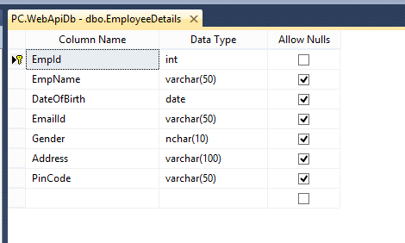

Note: If you already have an existing database and table, you can skip this step.

Step 2. Create a Web API Project

Now, we will create a Web API with the functionality of Create, Replace, Update, and Delete (CRUD) operations.

Open Visual Studio >> File >> New >> Project >> Select Web Application. After that click OK and you will see the templates. Select the Web API template.

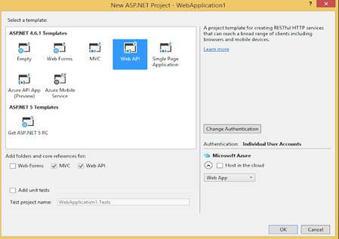

Click OK.

Step 3. Add ADO.NET Entity Data Model

Now, Select Models folder >> Right click >>Add >> New Item >> select Data in left panel >>ADO.NET Entity Data Model,

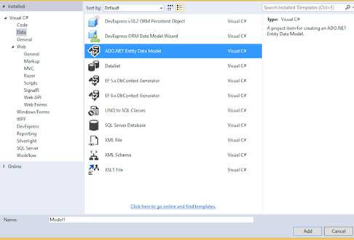

Now click Add button then select EF Designer from database >> Next >> After that give your SQL credential and select the database where your database table and data are.

Click the Add button and select your table and click on the Finish button.

Step 4. CRUD Operations

Now, we will write code to perform CRUD operation.

Go to the Controller folder in our API Application and right click >> Add >> Controller >> Select Web API 2 Controller-Empty

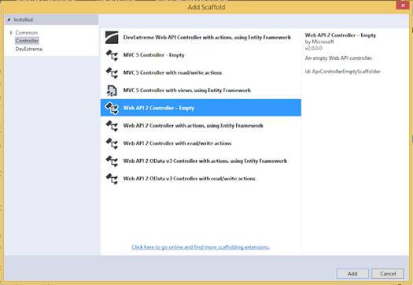

Now, we will go to the controller class and set the routing to make it more user friendly by writing the below code.
- using System;
- using System.Linq;
- using System.Web.Http;
- using CRUDAPI.Models;

- namespace CRUDAPI.Controllers
- {
- [RoutePrefix("Api/Employee")]
- public class EmployeeAPIController : ApiController
- {
- WebApiDbEntities objEntity = new WebApiDbEntities();

- [HttpGet]
- [Route("AllEmployeeDetails")]
- public IQueryable<EmployeeDetail> GetEmaployee()
- {
- try
- {
- return objEntity.EmployeeDetails;
- }
- catch(Exception)
- {
- throw;
- }
- }

- [HttpGet]
- [Route("GetEmployeeDetailsById/{employeeId}")]
- public IHttpActionResult GetEmaployeeById(string employeeId)
- {
- EmployeeDetail objEmp = new EmployeeDetail();
- int ID = Convert.ToInt32(employeeId);
- try
- {
- objEmp = objEntity.EmployeeDetails.Find(ID);
- if (objEmp == null)
- {
- return NotFound();
- }

- }
- catch (Exception)
- {
- throw;
- }

- return Ok(objEmp);
- }

- [HttpPost]
- [Route("InsertEmployeeDetails")]
- public IHttpActionResult PostEmaployee(EmployeeDetail data)
- {

- if (!ModelState.IsValid)
- {
- return BadRequest(ModelState);
- }
- try
- {
- objEntity.EmployeeDetails.Add(data);
- objEntity.SaveChanges();
- }
- catch(Exception)
- {
- throw;
- }

- return Ok(data);
- }

- [HttpPut]
- [Route("UpdateEmployeeDetails")]
- public IHttpActionResult PutEmaployeeMaster(EmployeeDetail employee)
- {
- if (!ModelState.IsValid)
- {
- return BadRequest(ModelState);
- }

- try
- {
- EmployeeDetail objEmp = new EmployeeDetail();
- objEmp = objEntity.EmployeeDetails.Find(employee.EmpId);
- if (objEmp != null)
- {
- objEmp.EmpName = employee.EmpName;
- objEmp.Address = employee.Address;
- objEmp.EmailId = employee.EmailId;
- objEmp.DateOfBirth = employee.DateOfBirth;
- objEmp.Gender = employee.Gender;
- objEmp.PinCode = employee.PinCode;

- }
- int i = this.objEntity.SaveChanges();

- }
- catch(Exception)
- {
- throw;
- }
- return Ok(employee);
- }
- [HttpDelete]
- [Route("DeleteEmployeeDetails")]
- public IHttpActionResult DeleteEmaployeeDelete(int id)
- {
- //int empId = Convert.ToInt32(id);
- EmployeeDetail emaployee = objEntity.EmployeeDetails.Find(id);
- if (emaployee == null)
- {
- return NotFound();
- }

- objEntity.EmployeeDetails.Remove(emaployee);
- objEntity.SaveChanges();

- return Ok(emaployee);
- }
- }
- }
As you may see from the above code, it has functionality to add, replace, update, and delete records to the table.

Step 5. Build UI Application

Now, we create the Web application in Angular 7 that will consume Web API.

First we have to make sure that we have Angular CLI installed.

Open command prompt and type below code and press ENTER:

npm install -g @angular/cli

Now, open Visual Studio Code and create a project.

Open TERMINAL in Visual Studio Code and type the following syntax to create a new project. We name it Angularcrud.

ng new Angularcrud

After that, hit ENTER. It will take a while to create the project.

Once created, the project should look like this.

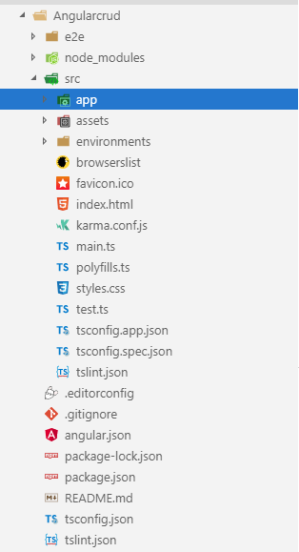

Now, we can create some components to provide the UI.

I'm going to create a new component, Employee.

Go to the TERMINAL and go our angular project location using the following command:

cd projectName

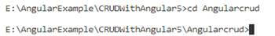

Now, write the following command that will create a component.

ng g c employee

Press ENTER.

Note: you can use see the component is created.

Step 6. Create a Service

Now, we will create a service.

Open the TERMINAL and write the below command:

ng g s employee

Press ENTER and you will see two service files.

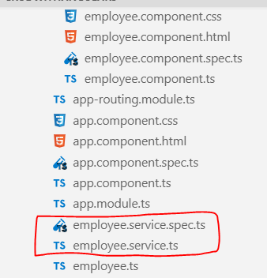

Now, we create a class like model class.

Open TERMINAL and write the below command:

ng g class employee

Now, write all properties of the Employee class related to an employee that matches with the database.
- export class Employee {
- EmpId: string;
- EmpName: string;
- DateOfBirth: Date;
- EmailId: string;
- Gender: string;
- Address: string;
- PinCode: string;
- }
Now, open employee.service.ts and first import necessary class and libraries and then make calls to the WebAPI methods.
- import { Injectable } from '@angular/core';
- import { HttpClient } from '@angular/common/http';
- import { HttpHeaders } from '@angular/common/http';
- import { Observable } from 'rxjs';
- import { Employee } from './employee';

- After that we write all methods related to consume web in employee.service.ts
- @Injectable({
- providedIn: 'root'
- })

- export class EmployeeService {
- url = 'http://localhost:65389/Api/Employee';
- constructor(private http: HttpClient) { }
- getAllEmployee(): Observable<Employee[]> {
- return this.http.get<Employee[]>(this.url + '/AllEmployeeDetails');
- }
- getEmployeeById(employeeId: string): Observable<Employee> {
- return this.http.get<Employee>(this.url + '/GetEmployeeDetailsById/' + employeeId);
- }
- createEmployee(employee: Employee): Observable<Employee> {
- const httpOptions = { headers: new HttpHeaders({ 'Content-Type': 'application/json'}) };
- return this.http.post<Employee>(this.url + '/InsertEmployeeDetails/',
- employee, httpOptions);
- }
- updateEmployee(employee: Employee): Observable<Employee> {
- const httpOptions = { headers: new HttpHeaders({ 'Content-Type': 'application/json'}) };
- return this.http.put<Employee>(this.url + '/UpdateEmployeeDetails/',
- employee, httpOptions);
- }
- deleteEmployeeById(employeeid: string): Observable<number> {
- const httpOptions = { headers: new HttpHeaders({ 'Content-Type': 'application/json'}) };
- return this.http.delete<number>(this.url + '/DeleteEmployeeDetails?id=' +employeeid,
- httpOptions);
- }
- }
Our service is completed now.

If you consume the Web API, Angular blocks the URL and we called this issue CORS(Cross OriginResource Sharing).

First, let's resolve this problem.

Go to the Web API project.

Download a Nuget package for CORS. Go to NuGet Package Manager and download the following file.

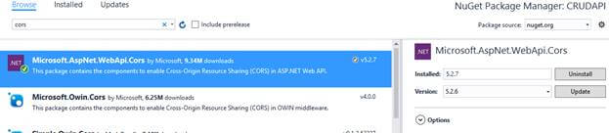

After that, go to App_Start folder in Web API project and open WebApiConfig.cs class. Here, modify the Register method with the below code.
- Add namespace
- using System.Web.Http.Cors;
- var cors = new EnableCorsAttribute("*","*","*");//origins,headers,methods
- config.EnableCors(cors);
Step 7. Install and Configure Angular Material Theme

As I said earlier, we will use the Angular Material theme to create a rich, interactive, and device-oriented UI for our Web app.

Let's install Install Angular Material theme.

Open TERMINAL again and write the below command:

npm install --save @angular/material @angular/cdk @angular/animations

If you want to learn more about Angular Material, visit here: link.

After installed successfully, we can check in package.json file.

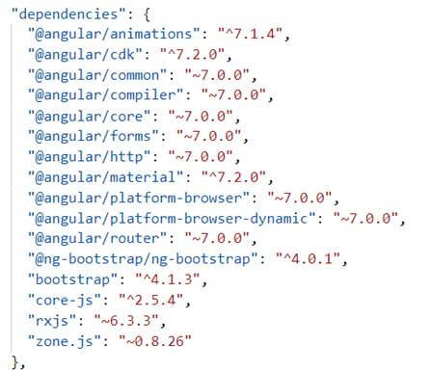

Now, let's all required libraries in app.module.ts. We also import a date picker because we'll use the date picker for date of birth field.

Now, open app.module.ts class and write the below code.
- import { BrowserModule } from '@angular/platform-browser';
- import { NgModule } from '@angular/core';
- import { EmployeeService } from './employee.service';
- import { FormsModule, ReactiveFormsModule } from '@angular/forms';
- import { HttpClientModule, HttpClient } from '@angular/common/http';
- import {
- MatButtonModule, MatMenuModule, MatDatepickerModule,MatNativeDateModule , MatIconModule, MatCardModule, MatSidenavModule,MatFormFieldModule,
- MatInputModule, MatTooltipModule, MatToolbarModule
- } from '@angular/material';
- import { MatRadioModule } from '@angular/material/radio';
- import { BrowserAnimationsModule } from '@angular/platform-browser/animations';

- import { AppRoutingModule } from './app-routing.module';
- import { AppComponent } from './app.component';
- import { EmployeeComponent } from './employee/employee.component';

- @NgModule({
- declarations: [
- AppComponent,
- EmployeeComponent
- ],
- imports: [
- BrowserModule,
- FormsModule,
- ReactiveFormsModule,
- HttpClientModule,
- BrowserAnimationsModule,
- MatButtonModule,
- MatMenuModule,
- MatDatepickerModule,
- MatNativeDateModule,
- MatIconModule,
- MatRadioModule,
- MatCardModule,
- MatSidenavModule,
- MatFormFieldModule,
- MatInputModule,
- MatTooltipModule,
- MatToolbarModule,
- AppRoutingModule
- ],
- providers: [HttpClientModule, EmployeeService,MatDatepickerModule],
- bootstrap: [AppComponent]
- })
- export class AppModule { }
Now, we have to import library in styles.css file.
- @import '@angular/material/prebuilt-themes/indigo-pink.css';
Step 8. Design HTML

Let's design our HTML page now.

Open employee.component.html and write the below code.
- <div class="container">

- <mat-card>
- <mat-toolbar color="accent">
- <div align="center" style="color:white;text-align: right;">
- CRUD operation in Angular 7 using Web api and Sql Database
- </div>
- </mat-toolbar>
- <br><br>
- <mat-card-content>
- <form [formGroup]="employeeForm"(ngSubmit)="onFormSubmit(employeeForm.value)">
- <table>
- <tr>
- <td class="tbl1">
- <mat-form-field class="demo-full-width">
- <input formControlName="EmpName" matTooltip="Enter Employee Name" matInput placeholder="Employee Name">
- </mat-form-field>
- <mat-error>
- <span *ngIf="!employeeForm.get('EmpName').value && employeeForm.get('EmpName').touched"></span>
- </mat-error>
- </td>
- <td class="tbl1">
- <mat-form-field class="demo-full-width">
- <input matInput [matDatepicker]="picker"matTooltip="Enter Date Of Birth" formControlName="DateOfBirth"placeholder="Choose Date Of Birth">
- <mat-datepicker-toggle matSuffix [for]="picker"></mat-datepicker-toggle>
- <mat-datepicker #picker></mat-datepicker>
- </mat-form-field>
- <mat-error>
- <span *ngIf="!employeeForm.get('DateOfBirth').value && employeeForm.get('DateOfBirth').touched"></span>
- </mat-error>
- </td>
- <td class="tbl1">
- <mat-form-field class="demo-full-width">
- <input formControlName="EmailId" matTooltip="Enter EmailId" matInput placeholder="EmailId">
- </mat-form-field>
- <mat-error>
- <span *ngIf="!employeeForm.get('EmailId').value && employeeForm.get('EmailId').touched"></span>
- </mat-error>
- </td>
- </tr>
- <tr>
- <td class="tbl1">
- <span>Gender</span>
- <br><br>
- <mat-radio-group matTooltip="Enter Gender"formControlName="Gender">
- <mat-radio-button value="0">Male</mat-radio-button>
- <mat-radio-button value="1">Female</mat-radio-button>
- </mat-radio-group>
- <mat-error>
- <span *ngIf="!employeeForm.get('Gender').value && employeeForm.get('Gender').touched"></span>
- </mat-error>
- </td>
- <td class="tbl1">
- <mat-form-field class="demo-full-width">
- <input matTooltip="Enter Address"formControlName="Address" matInput placeholder="Address">
- </mat-form-field>
- <mat-error>
- <span *ngIf="!employeeForm.get('Address').value && employeeForm.get('Address').touched"></span>
- </mat-error>
- </td>
- <td class="tbl1">
- <mat-form-field class="demo-full-width">
- <input formControlName="PinCode" matTooltip="Enter Pine Code" matInput placeholder="PinCode">
- </mat-form-field>
- <mat-error>
- <span *ngIf="!employeeForm.get('PinCode').value && employeeForm.get('PinCode').touched"></span>
- </mat-error>
- </td>
- </tr>
- <tr>
- <td></td>
- <td class="content-center">
- <button type="submit" mat-raised-button color="accent"matTooltip="Click Submit Button"[disabled]="!employeeForm.valid">Submit</button>
- <button type="reset" mat-raised-button color="accent"matTooltip="Click Reset Button" (click)="resetForm()">Reset</button>
- </td>
- <td>
- <p *ngIf="dataSaved" style="color:rgb(0, 128, 0);font-size:20px;font-weight:bold" Class="success" align="left">
- {{massage}}
- </p>
- </td>
- </tr>
- </table>
- <br><br>
- <table class="table" >
- <tr ngclass="btn-primary">
- <th class="tbl2">Employee Name</th>
- <th class="tbl2">Date Of Birth</th>
- <th class="tbl2">Email Id</th>
- <th class="tbl2">Gender</th>
- <th class="tbl2">Address</th>
- <th class="tbl2">Pine Code</th>
- <th class="tbl2">Edit</th>
- <th class="tbl2">Delete</th>
- </tr>
- <tr *ngFor="let employee of allEmployees | async">
- <td class="tbl2">{{employee.EmpName}}</td>
- <td class="tbl2">{{employee.DateOfBirth | date }}</td>
- <td class="tbl2">{{employee.EmailId}}</td>
- <td class="tbl2">{{employee.Gender ==0? 'Male' : 'Female'}}</td>
- <td class="tbl2">{{employee.Address}}</td>
- <td class="tbl2">{{employee.PinCode}}</td>
- <td class="tbl2">
- <button type="button" class="btn btn-info"matTooltip="Click Edit Button"(click)="loadEmployeeToEdit(employee.EmpId)">Edit</button>
- </td>
- <td class="tbl2">
- <button type="button" class="btn btn-danger"matTooltip="Click Delete Button"(click)="deleteEmployee(employee.EmpId)">Delete</button>
- </td>
- </tr>

- </table>
- </form>
- </mat-card-content>
- </mat-card>
- </div>
Step 9

Open app.component.html and write the below code.
- <p>
- <app-employee></app-employee>
- </p>
Step 10

Open employee.component.ts file and write the below code.
- import { Component, OnInit } from '@angular/core';
- import { FormBuilder, Validators } from '@angular/forms';
- import { Observable } from 'rxjs';
- import { EmployeeService } from '../employee.service';
- import { Employee } from '../employee';

- @Component({
- selector: 'app-employee',
- templateUrl: './employee.component.html',
- styleUrls: ['./employee.component.css']
- })
- export class EmployeeComponent implements OnInit {
- dataSaved = false;
- employeeForm: any;
- allEmployees: Observable<Employee[]>;
- employeeIdUpdate = null;
- massage = null;

- constructor(private formbulider: FormBuilder, private employeeService:EmployeeService) { }

- ngOnInit() {
- this.employeeForm = this.formbulider.group({
- EmpName: ['', [Validators.required]],
- DateOfBirth: ['', [Validators.required]],
- EmailId: ['', [Validators.required]],
- Gender: ['', [Validators.required]],
- Address: ['', [Validators.required]],
- PinCode: ['', [Validators.required]],
- });
- this.loadAllEmployees();
- }
- loadAllEmployees() {
- this.allEmployees = this.employeeService.getAllEmployee();
- }
- onFormSubmit() {
- this.dataSaved = false;
- const employee = this.employeeForm.value;
- this.CreateEmployee(employee);
- this.employeeForm.reset();
- }
- loadEmployeeToEdit(employeeId: string) {
- this.employeeService.getEmployeeById(employeeId).subscribe(employee=> {
- this.massage = null;
- this.dataSaved = false;
- this.employeeIdUpdate = employee.EmpId;
- this.employeeForm.controls['EmpName'].setValue(employee.EmpName);
- this.employeeForm.controls['DateOfBirth'].setValue(employee.DateOfBirth);
- this.employeeForm.controls['EmailId'].setValue(employee.EmailId);
- this.employeeForm.controls['Gender'].setValue(employee.Gender);
- this.employeeForm.controls['Address'].setValue(employee.Address);
- this.employeeForm.controls['PinCode'].setValue(employee.PinCode);
- });

- }
- CreateEmployee(employee: Employee) {
- if (this.employeeIdUpdate == null) {
- this.employeeService.createEmployee(employee).subscribe(
- () => {
- this.dataSaved = true;
- this.massage = 'Record saved Successfully';
- this.loadAllEmployees();
- this.employeeIdUpdate = null;
- this.employeeForm.reset();
- }
- );
- } else {
- employee.EmpId = this.employeeIdUpdate;
- this.employeeService.updateEmployee(employee).subscribe(() => {
- this.dataSaved = true;
- this.massage = 'Record Updated Successfully';
- this.loadAllEmployees();
- this.employeeIdUpdate = null;
- this.employeeForm.reset();
- });
- }
- }
- deleteEmployee(employeeId: string) {
- if (confirm("Are you sure you want to delete this ?")) {
- this.employeeService.deleteEmployeeById(employeeId).subscribe(() => {
- this.dataSaved = true;
- this.massage = 'Record Deleted Succefully';
- this.loadAllEmployees();
- this.employeeIdUpdate = null;
- this.employeeForm.reset();

- });
- }
- }
- resetForm() {
- this.employeeForm.reset();
- this.massage = null;
- this.dataSaved = false;
- }
- }
Step 11. Run

We have completed all needed code functionality for our CRUD operations. Before running the application, first, make sure to save your work.

Now, let's run the app and see how it works.

Open TERMINAL and write the following command to run the program.

ng serve -o

The output looks like the following image. It's a stunning UI created with CRUD operations.

